# **HTML**

## **Qno. 1:**

<!DOCTYPE html>

<html lang="en">

<head>

<meta charset="UTF-8">

<meta name="viewport" content="width=device-width, initial-scale=1.0">

<title>Pushpa Kaju HTML Qno.1 Displaying from <h1> to <h6> in different lines.</title>

</head>

<body>

<h1>This is &lt;h1&gt; text</h1>

<h2>This is &lt;h2&gt; text</h2>

<h3>This is &lt;h3&gt; text</h3>

<h4>This is &lt;h4&gt; text</h4>

<h5>This is &lt;h5&gt; text</h5>

<h6>This is &lt;h6&gt; text</h6>

</body>

</html>

**OUTPUT**

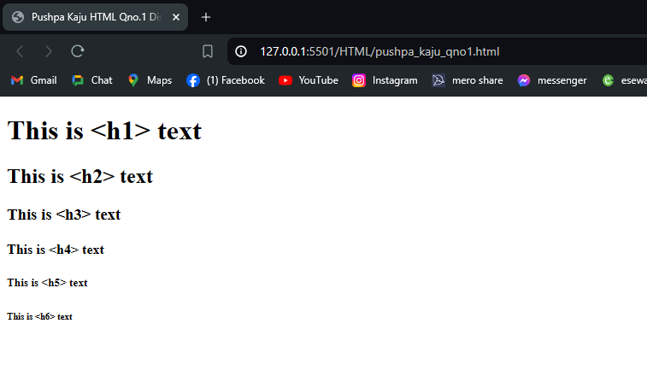

## **Qno. 2:**

<!DOCTYPE html>

<html lang="en">

<head>

<meta charset="UTF-8">

<meta name="viewport" content="width=device-width, initial-scale=1.0">

<title>Pushpa Kaju HTML Qno. 2: Insert a paragraph in the following format</title>

</head>

<body>

<pre>

<font face="Times new roman" >

<p>

Hello, World! This

is a

<i> formatted paragraph</i> in my own

style dine using html tag.

<strong><i>-Web Tech Lab</i></strong>

</p>

</font>

</pre>

</body>

</html>

**OUTPUT:**

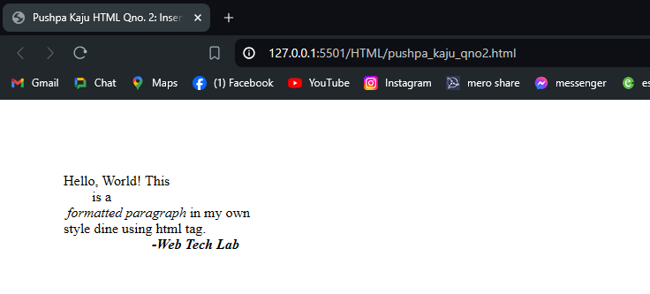

## **Qno. 3:**

<!DOCTYPE html>

<html lang="en">

<head>

<meta charset="UTF-8">

<meta name="viewport" content="width=device-width, initial-scale=1.0">

<title>Pushpa Kaju HTML Qno. 3: Insert a audio, image and video with it's controls along with height= 300px and

width=400px.</title>

</head>

<body>

<h3>Audio</h3>

<audio controls height="300px" width="400px" src="./resources/starboy-weekend.mp3">

</audio>

<h3>Image</h3>

<img src="./resources/ktm-durbar.jpg" alt="Kathmandu Durbar Square" height="300px" width="400px">

<h3>Video</h3>

<video controls height="300px" width="400px" src="./resources/rain-video.mp4">

</body>

</html>

**OUTPUT:**

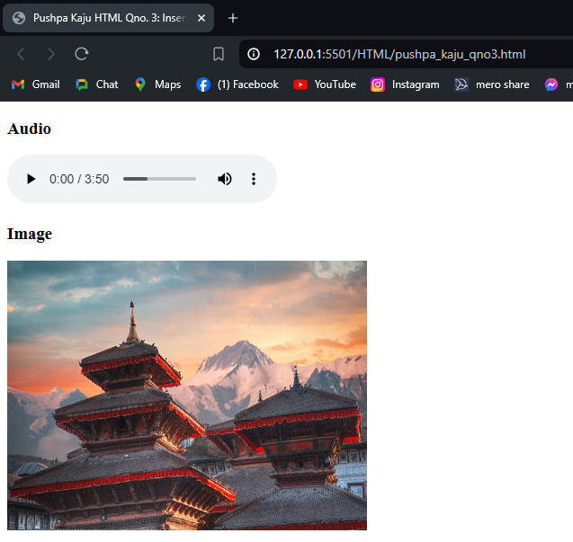

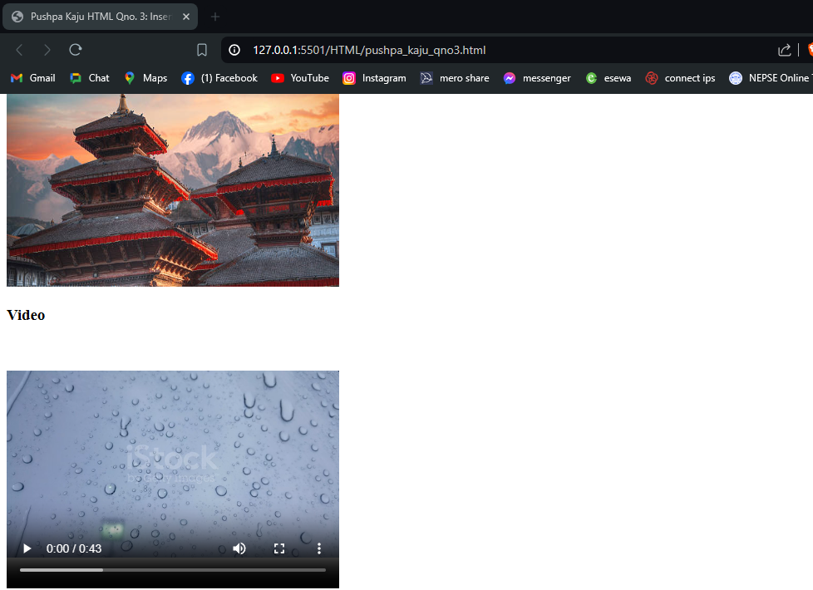

## **Qno. 4:**

<!DOCTYPE html>

<html lang="en">

<head>

<meta charset="UTF-8">

<meta name="viewport" content="width=device-width, initial-scale=1.0">

<title>Pushpa Kaju HTML Qno. 4: Designing following table</title>

<style>

.table1,

.table2 {

border-collapse: collapse;

}

.table2 th,

.table2 td {

border: 1px solid black;

text-align: start;

padding-right: 5px;

padding-left: 5px;

}

.table1 th,

.table1 td {

border: 1px solid black;

text-align: start;

padding-right: 30px;

padding-left: 10px;

}

.table {

margin: 20px;

}

body {

display: flex;

justify-content: left;

align-items: flex-end;

}

</style>

</head>

<body>

<div class="table">

<table class="table1" align="left">

<caption><b>Student Result</b></caption>

<tr>

<th>Name</th>

<th>Subject</th>

<th>Marks</th>

</tr>

<tr>

<td rowspan="2">Hilary</td>

<td>Advance Web</td>

<td>75</td>

</tr>

<tr>

<td>OS</td>

<td>60</td>

</tr>

<tr>

<td rowspan="2">Larry</td>

<td>Advance Web</td>

<td>80</td>

</tr>

<tr>

<td>OS</td>

<td>75</td>

</tr>

<tr>

<td colspan="3" style="text-align: center;">Total Average=72.5</td>

</tr>

</table>

</div>

<div class="table">

<table class="table2">

<caption><b>Sales-Profit</b></caption>

<tr>

<th colspan="2">October</th>

<th colspan="2">November</th>

</tr>

<tr>

<td>Sales</td>

<td>Profit</td>

<td>Sales</td>

<td>Profit</td>

</tr>

<tr>

<td>$20000</td>

<td>$50000</td>

<td>$30000</td>

<td>$70000</td>

</tr>

<tr>

<th colspan="4" style="text-align: center;">November was more<br> productive</th>

</tr>

</table>

</div>

</body>

</html>

**OUTPUT:**

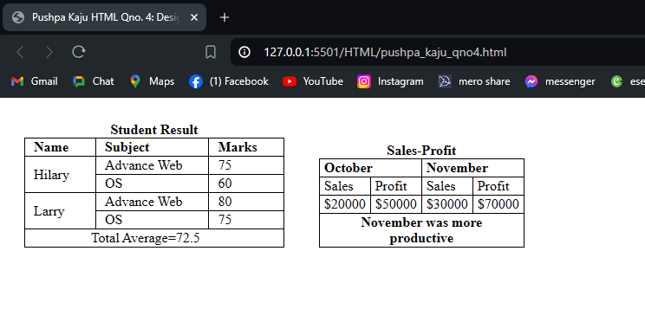

## **Qno. 5:**

<!DOCTYPE html>

<html lang="en">

<head>

<meta charset="UTF-8">

<meta name="viewport" content="width=device-width, initial-scale=1.0">

<title>Pushpa Kaju HTML Qno. 5: Create the exact table as below </title>

<style>

table {

text-align: center;

border-collapse: collapse;

}

th,

td {

border: 1px solid black;

padding: 5px 30px;

}

</style>

</head>

<body>

<table cellpadding='20px'>

<tr>

<th colspan="6" style="padding: 20px 500px;">

<center>First Assessment Routine</center>

</th>

</tr>

<tr>

<td rowspan="4" style="padding: 0px 90px;">Academic Year 2024</td>

</tr>

<tr>

<th>Batch/Time</th>

<td>9:00</td>

<td>10:00</td>

<td>11:00</td>

<td>12:00</td>

</tr>

<tr>

<td>BIM</td>

<td>WT</td>

<td colspan="2">Break</td>

<td>Java</td>

</tr>

<tr>

<td>BIT</td>

<td>DAA</td>

<td>OOP</td>

<td colspan="2">Break</td>

</tr>

</table>

</body>

</html>

**OUTPUT:**

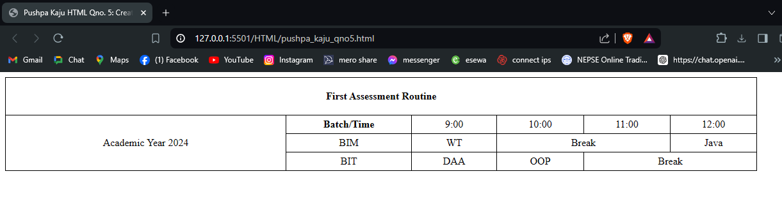

## **Qno. 6:**

<!DOCTYPE html>

<html lang="en">

<head>

<meta charset="UTF-8">

<meta name="viewport" content="width=device-width, initial-scale=1.0">

<title>Pushpa Kaju HTML Qno. 6: Create following nested table structure</title>

<style>

body {

font-family: 'calibri';

}

</style>

</head>

<body>

<h3>Nested Tables</h3>

<table border="1">

<tr>

<th>Header column 1</th>

<th>Header column 2</th>

<th>Header column 3</th>

<th>Header column 4</th>

</tr>

<tr>

<td>Row 2 - Item 1</td>

<td>Row 2 - Item 3</td>

<td rowspan="2">

<br>

<b>

Row 2 - Nested Table 1

</b>

<br>

<br>

<table border="1">

<tr>

<th>Row 1 Header</th>

<td>item</td>

</tr>

<tr>

<th>Row 2 Header</th>

<td>item</td>

</tr>

<tr>

<th>Row 3 Header</th>

<td>item</td>

</tr>

</table>

</td>

<td>Row 2 - Item 4 <br> A second line</td>

</tr>

<tr>

<td>

<br>

<b>

Row 3 - Nested Table 2

</b>

<br>

<br>

<table border="1">

<tr>

<th>Row 1 Header</th>

<td>item</td>

</tr>

<tr>

<th>Row 2 Header</th>

<td>item</td>

</tr>

</table>

</td>

<td>Row 3 - Item 2</td>

<td rowspan="2">Row 3 - Item 3</td>

</tr>

<tr>

<td>Row 4 - Item 1</td>

<td>Row 4 - Item 2</td>

<td>Row 4 - Item 3</td>

</tr>

<tr>

<td colspan="4">Row 5 - Last row of outer table</td>

</tr>

</table>

</body>

</html>

**OUPUT:**

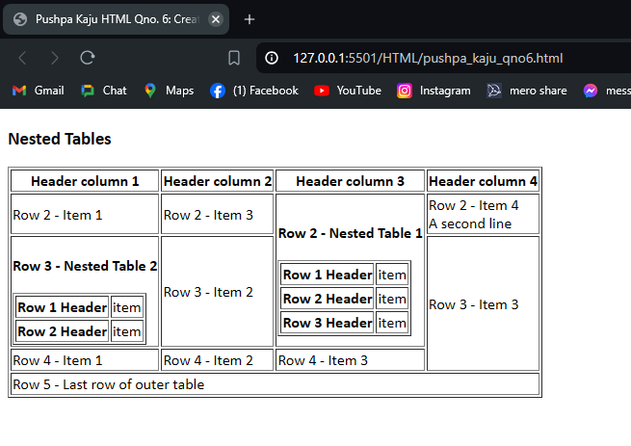

## **Qno. 7:**

<!DOCTYPE html>

<html lang="en">

<head>

<meta charset="UTF-8">

<meta name="viewport" content="width=device-width, initial-scale=1.0">

<title>Pushpa Kaju HTML Qno. 7: Create the following form. Include

placeholder, radio type, pattern for

the contact information, set limit

for birthday to current day. Provide

options and group them according

to their category.</title>

</head>

<body>

<fieldset>

<legend>Personal Information</legend>

<form action="">

<label for="fullname" style="color: aqua;">Full Name:</label>

<input type="text" id="fullname" name="fullname" placeholder="Yout fullname" required>

<br>

<label for="current-city">Current City:</label>

<input type="text" id="current-city" name="current-city" placeholder="where is your city" required>

<br>

<label for="email">Email:</label>

<input type="email" id="email" name="email" placeholder="example@gmail.com" required>

<br>

<label for="phone">phone:</label>

<input type="number" id="phone" name="phone" placeholder="9*********" required>

<br>

<label for="gender">Gender:</label>

<input type="radio" id="male" name="gender" value="male">

<label for="male">Male</label>

<input type="radio" id="female" name="gender" value="female">

<label for="female">Female</label>

<br>

<label for="dob">Birthday:</label>

<input type="date" id="dob" name="dob" required>

<br>

<label for="car">Choose Car Company:</label>

<select name="car" id="car">

<option value="Jeep">Jeep</option>

<option value="BMW">BMW</option>

<option value="Toyota">Toyota</option>

<option value="Nissan">Nissan</option>

<option value="Ford">Ford</option>

<option value="Tesla">Tesla</option>

</select>

<br>

<label for="add">Additional Information:</label><br>

<textarea name="add" id="add" cols="30" rows="10"></textarea>

<br>

<input type="checkbox" id="terms" name="terms" required>

<label for="terms">I agree to the terms and policy</label>

<br>

<input type="submit" value="Submit">

<input type="reset" value="Reset">

</form>

</fieldset>

</body>

</html>

**OUTPUT:**

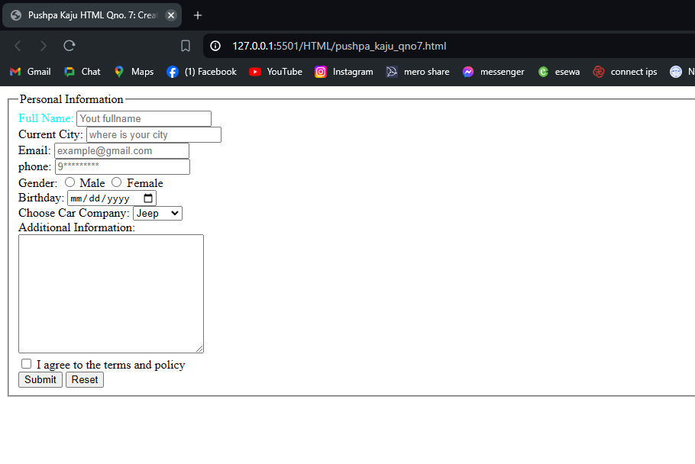

## **Qno. 8:**

<!DOCTYPE html>

<html lang="en">

<head>

<meta charset="UTF-8">

<meta name="viewport" content="width=device-width, initial-scale=1.0">

<title>Pushpa Kaju HTML Qno. 8: Create the following form as

exactly shown in there.</title>

<style>

.highlight {

color: blue;

font-weight: bold;

}

.info {

display: flex;

justify-content: space-between;

width: 25%;

}

</style>

</head>

<body>

<fieldset>

<legend>Survey Form</legend>

<form>

<!-- contact info -->

<h3>Contact Information</h3>

<div class='info'>

<label for="email" class="highlight">Email Address:</label>

<input type="email" id="email" name="email" required>

</div>

<div class='info'>

<label for="fname" class="highlight">First Name:</label>

<input type="text" id="fname" name="fname" required>

</div>

<div class='info'>

<label for="lname" class="highlight">Last Name:</label>

<input type="text" id="lname" name="lname" required>

</div>

<!-- geo information -->

<h3>Geographic Information</h3>

<div class='info'>

<label for="state" class="highlight">State:</label>

<input type="text" id="state" name="state" required>

</div>

<div class='info'>

<label for="zip" class="highlight">Zip Code:</label>

<input type="text" id="zip" name="zip" required>

</div>

<!-- how did you heat abt us -->

<h3>How did you hear about us?</h3>

<input type="checkbox" id="web" name="web" value="web">

<label for="web">websearch</label>

<br>

<input type="checkbox" id="fb" name="fb" value="fb">

<label for="fb">facebook</label>

<br>

<input type="checkbox" id="twt" name="twt" value="twt">

<label for="twt">websearch</label>

<br>

<input type="checkbox" id="email" name="email" value="email">

<label for="email">email message</label>

<!-- Suggenstions -->

<h3>Any Suggestions</h3>

<textarea name="suggestions" id="suggestions" cols="30" rows="10"></textarea>

<h3>Thank You for taking our survey.</h3>

<input type="submit" value="Submit">

<input type="reset" value="Reset">

</form>

</fieldset>

</body>

</html>

**OUTPUT:**

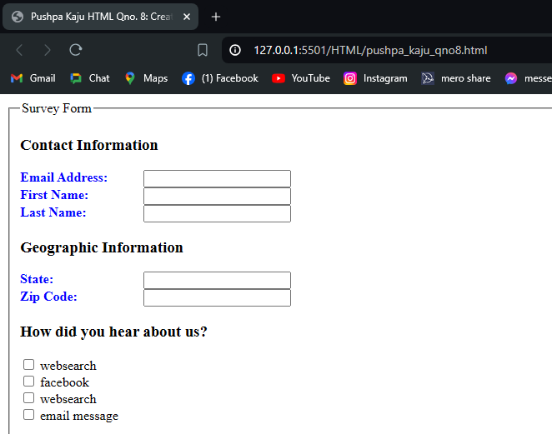

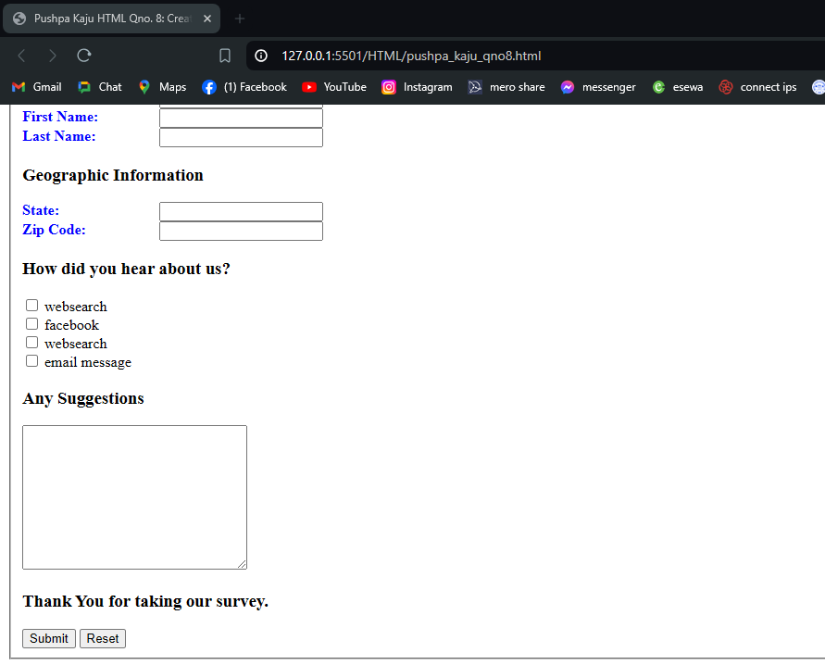

## **Qno. 9:**

<!DOCTYPE html>

<html lang="en">

<head>

<meta charset="UTF-8">

<meta name="viewport" content="width=device-width, initial-scale=1.0">

<title>Pushpa Kaju HTML Qno. 9: Listing the items using ordered list, unordered list, data definition list.</title>

<style>

body {

display: flex;

justify-content: space-around;

width: 50%;

}

</style>

</head>

<body>

<ul>

<li>Apple</li>

<li>Banana</li>

<li>Guava</li>

<li>Papaya</li>

</ul>

<ol>

<li>Apple</li>

<li>Banana</li>

<li>Guava</li>

<li>Papaya</li>

</ol>

<dl>

<dt>Coffee</dt>

<dd>- black hot drink</dd>

<dt>Milk</dt>

<dd>- white cold drink</dd>

</dl>

</body>

</html>

**OUTPUT:**

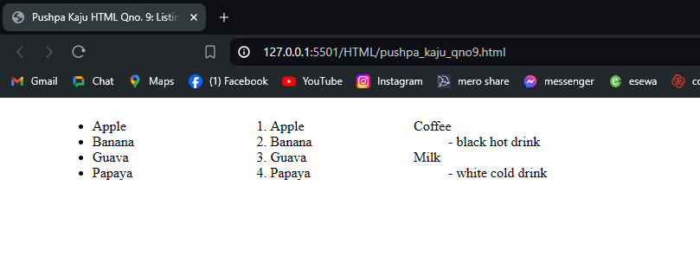

# **HTML & CSS**

## **Qno. 1:**

**HTML**

<!DOCTYPE html>

<html lang="en">

<head>

<meta charset="UTF-8">

<meta name="viewport" content="width=device-width, initial-scale=1.0">

<link rel="stylesheet" href="../Style/qno1.css">

<title>Pushpa Kaju HTML & CSS Qno. 1: Display following CSS Box model using html and CSS. </title>

</head>

<body>

<div class="margin">

Margin

<div class="border">

Border

<div class="padding">

Padding

<div class="content">

Content

</div>

</div>

</div>

</div>

</body>

</html>

**CSS**

.margin {

border: 1px solid black;

width: 250px;

}

.border {

margin: 10px;

border: 10px solid black;

}

.padding {

padding: 10px;

margin: 10px;

border: 5px dotted blue;

}

.content {

height: 100px;

/* width: 100px; */

border: 2px solid red;

text-align: center;

}

**OUTPUT:**

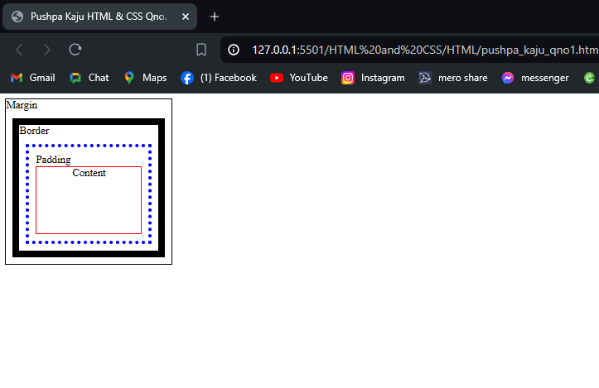

## **Qno. 2:**

**HTML**

<!DOCTYPE html>

<html lang="en">

<head>

<meta charset="UTF-8">

<meta name="viewport" content="width=device-width, initial-scale=1.0">

<title>Pushpa Kaju HTML & CSS Qno 2:</title>

<link rel="stylesheet" href="../Style/qno2.css">

</head>

<body>

<div class="content">

<br>

Lorem ipsum dolor sit amet consectetur adipisicing elit. Dolore dolores, vel perferendis ab, incidunt sint alias assumenda maiores eum, odit inventore necessitatibus fuga excepturi sed dolor ullam. Quidem, harum tenetur!

</div>

<div class="content">

Lorem ipsum, dolor sits amet consectetur adipisicing elit. Quidem corporis aut velit consequuntur illum solute maxime deleniti doloremque earum ipsa similique neque consectetur explicabo, libero praesentium necessitatibus, voluptatum iusto. Impedit!

</div>

<div class="content last">

Lorem ipsum dolor sit amet consectetur adipisicing elit. Consequatur, aspernatur itaque. Aliquam sequi sit quam rem dicta optio quibusdam, atque id delectus quod cupiditate officia voluptates inventore iusto in quis.

</div>

</body>

</html>

**CSS**

body {

display: flex;

}

.content {

border-right: 1px solid grey;

margin-left: 10px;

}

.last {

border-right: none;

}

**OUTPUT:**

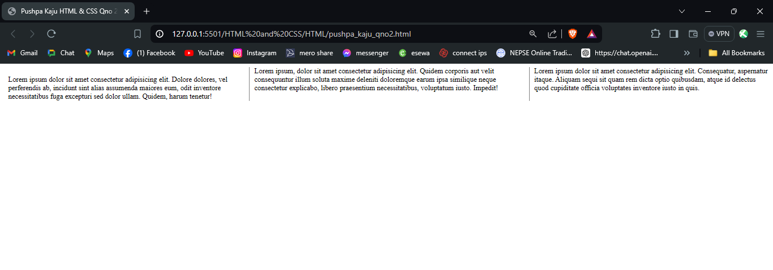

## **Qno. 3:**

**HTML**

<!DOCTYPE html>

<html lang="en">

<head>

<meta charset="UTF-8">

<meta name="viewport" content="width=device-width, initial-scale=1.0">

<title>Pushpa Kaju HTML & CSS Qno 3: Use CSS selectors(universal selector, element-element selector, element grouping selector, id and class selector) to display as follows.</title>

<link rel="stylesheet" href="../Style/qno3.css">

</head>

<body>

<header>

<h2>

Welcome to my website.

</h2>

</header>

<nav>

<ul>

<li><a href="#home">Home</a></li>

<li><a href="#about">About</a></li>

<li><a href="#service">Services</a></li>

<li><a href="#contact">Contact</a></li>

</ul>

</nav>

<div id="content">

<div class="section" id="home">

<div class="title">

Home

</div>

<div class="content">

Welcome to home page!

</div>

</div>

<div class="section" id="about">

<div class="title">

About

</div>

<div class="content">

Learn more about me and my background.

</div>

</div>

<div class="section" id="service">

<div class="title">

Services

</div>

<div class="content">

Check out the service I offer.

</div>

</div>

<div class="section" id="contact">

<div class="title">

Contact

</div>

<div class="content">

Get in touch with me.

</div>

</div>

</div>

</body>

</html>

**CSS**

/* universal selector */

* {

background-color: #333333;

color: white;

}

/* element selector */

header {

color: white;

text-align: center;

}

/* element-element seelctor */

nav ul {

display: flex;

list-style-type: none;

justify-content: space-around;

align-items: center;

margin: 0;

padding: 10px 0px;

}

ul li a {

text-decoration: none;

transition: all 0.5s;

}

ul li a:hover {

color: grey;

text-decoration: underline;

}

/* id selector */

#content {

margin-bottom: 30px;

}

/* element-group selector */

div,

nav,

ul,

li {

background-color: transparent;

}

/* class selector */

.section {

padding: 35px;

color: black;

}

#home {

background-color: #f9c74f;

}

.title {

color: black;

font-weight: bold;

font-size: x-large;

}

.content {

color: black;

}

#about {

background-color: #e74c3c;

}

#service {

background-color: #2ecc71;

}

#contact {

background-color: #3498db;

}

**OUTPUT**

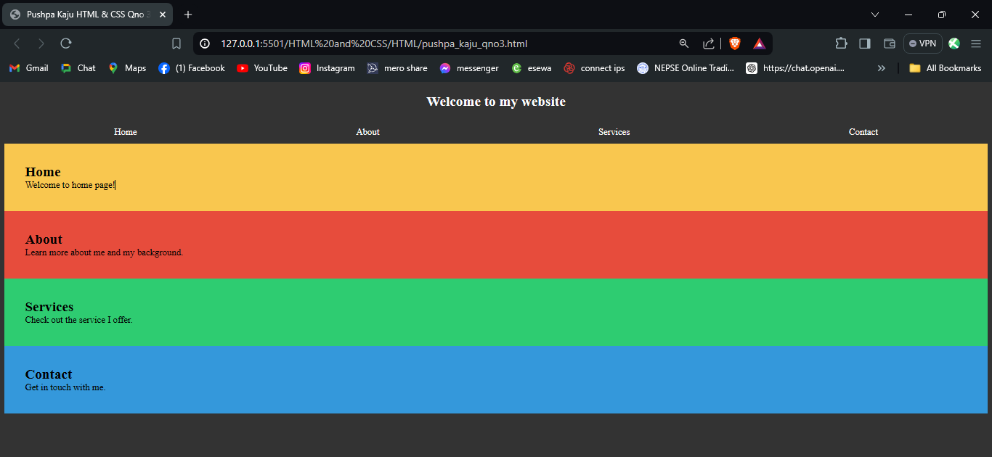

## **Qno. 4:**

**HTML**

<!DOCTYPE html>

<html lang="en">

<head>

<meta charset="UTF-8">

<meta name="viewport" content="width=device-width, initial-scale=1.0">

<title>Pushpa Kaju HTML & CSS Qno 4: Use CSS attribute selectors to select and style the different elements of a html

document.</title>

<link rel="stylesheet" href="../Style/qno4.css">

</head>

<body>

<h1>CSS Attribute Selectors</h1>

<p>Here are some examples of attribute selectors:</p>

<ul>

<li>

<a href="https://www.youtube.com/watch?v=kAJz7c97Cyo&list=RDkAJz7c97Cyo&start_radio=1" class="external-link">External link</a>

</li>

<li>

<a href="https://www.youtube.com/watch?v=kAJz7c97Cyo&list=RDkAJz7c97Cyo&start_radio=1" class="internal-link">Internal link</a>

</li>

<li>

<a href="https://www.youtube.com/watch?v=kAJz7c97Cyo&list=RDkAJz7c97Cyo&start_radio=1" class="parent-link">Parent link</a>

</li>

<li>

<a href="https://www.youtube.com/watch?v=kAJz7c97Cyo&list=RDkAJz7c97Cyo&start_radio=1" class="top-link">Top

link</a>

</li>

<li>

<a href="https://www.youtube.com/watch?v=kAJz7c97Cyo&list=RDkAJz7c97Cyo&start_radio=1" class="highlighted-link">Highlighted link</a>

</li>

</ul>

</body>

</html>

**CSS**

a[class="external-link"] {

background-color: #2ecc71;

}

a[class="internal-link"] {

background-color: #2ecc71;

}

a[class="parent-link"] {

background-color: #2ecc71;

}

a[class="top-link"] {

background-color: #2ecc71;

}

a[class="highlighted-link"] {

background-color: #2ecc71;

}

**OUTPUT**

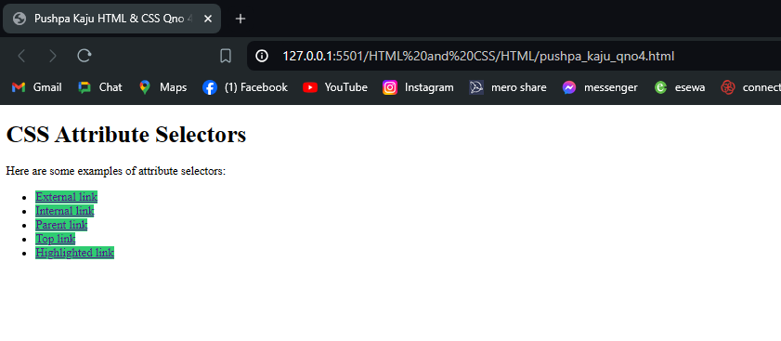

## **Qno. 5:**

**HTML**

<!DOCTYPE html>

<html lang="en">

<head>

<meta charset="UTF-8">

<meta name="viewport" content="width=device-width, initial-scale=1.0">

<title>Pushpa Kaju HTML & CSS Qno 5: Use CSS Pseudo-class Selectors on a anchor<a> and input. </title>

<link rel="stylesheet" href="../Style/qno5.css">

</head>

<body>

<h1>CSS Pseudo-class Selectors</h1>

<p>Here are some examples of attribute selectors:</p>

<ul>

<li>

<a href="#">Home</a>

</li>

<li>

<a href="#">Contact</a>

</li>

<li>

<a href="#">About</a>

</li>

</ul>

<form>

<label for="username">Name:</label>

<input type="text" id="username" name="username"><br>

<label for="email">Email:</label>

<input type="email" id="email" name="eail"><br>

<input type="submit" value="Submit">

</form>

<p>Hover over the link to see the hover pseudo-class in action.</p>

<p>Fill in the form fields to see the focus and active pseudo-classes in action.</p>

</body>

</html>

**CSS**

a:hover {

color: grey;

}

a:active {

color: red;

}

input[type="text"]:focus,

input[type="email"]:focus {

background-color: yellow;

}

input[type="text"]:active,

input[type="email"]:active {

background-color: green;

}

**OUTPUT:**

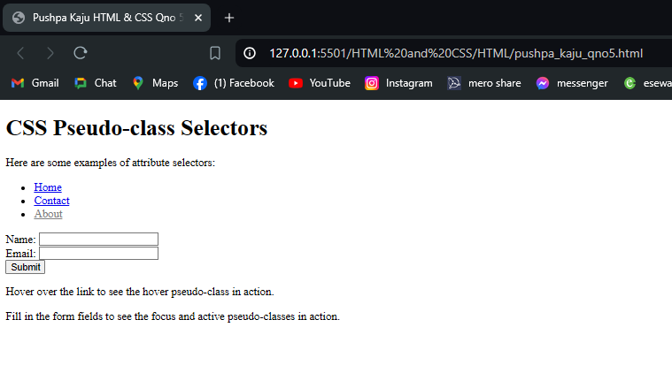

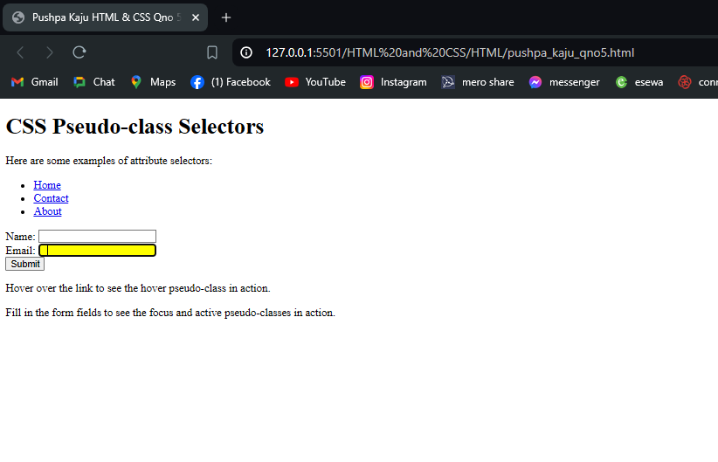

## **Qno. 6:**

**HTML**

<!DOCTYPE html>

<html lang="en">

<head>

<meta charset="UTF-8">

<meta name="viewport" content="width=device-width, initial-scale=1.0">

<link rel="stylesheet" href="../Style/qno6.css">

<title>Pushpa Kaju HTML & CSS Qno 6: Write CSS for Pseudo class selector to add before and after a paragraph</title>

</head>

<body>

<h1>CSS Pseudo-element Selectors</h1>

<p>Here are some examples of usinf all the basic pseudo-element selectors</p>

<div class="childs">

<p>

Lorem ipsum dolor sit amet consectetur adipisicing elit. Eum repellendus aperiam ea impedit minima vel

debitis. Quo accusamus laudantium distinctio, officiis error voluptate. Animi similique beatae veniam illum

incidunt hic?

</p>

<p>

Lorem ipsum dolor sit amet consectetur adipisicing elit. Similique, accusantium voluptate. Dicta totam

commodi debitis laborum recusandae, nam nulla ut, esse expedita pariatur ratione reiciendis iusto culpa

omnis et vel?

</p>

<p>

Lorem ipsum dolor sit amet consectetur adipisicing elit. Fugit ad consequuntur eius aspernatur maiores ab,

esse tenetur officiis mollitia a itaque nemo autem quo reiciendis soluta, at libero repellendus beatae.

</p>

<p>

Lorem ipsum dolor sit amet consectetur adipisicing elit. Mollitia temporibus cupiditate aliquam quaerat

natus possimus porro magnam sit accusamus dolor incidunt aut commodi esse vitae in maiores, assumenda

voluptatum rerum.

</p>

</div>

<p>Before and after:</p>

<p class="before">Before</p>

<p class="after">After</p>

</body>

</html>

**CSS**

.childs p:first-child {

color: red;

font-size: x-large;

}

.childs p:nth-child(2) {

color: blue;

font-weight: bold;

}

.childs p:nth-child(3) {

background-color: wheat;

}

.childs p:last-child {

margin-left: 50px;

}

.before::before {

content: "Before: Added Hi! ";

color: blue;

}

.after::after {

content: " After: Added Bye!";

color: red;

}

**OUTPUT**

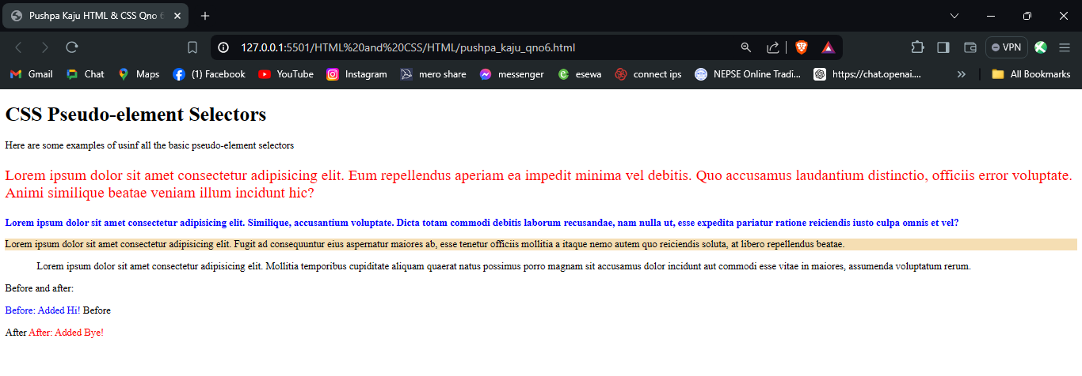

## **Qno. 7:**

**HTML**

<!DOCTYPE html>

<html lang="en">

<head>

<meta charset="UTF-8">

<meta name="viewport" content="width=device-width, initial-scale=1.0">

<title>Pushpa Kaju HTML & CSS Qno 7: Display property inline, inline-block and block</title>

<link rel="stylesheet" href="../Style/qno7.css">

</head>

<body>

<h1>The display Property</h1>

<h2>display: inline</h2>

<p class="inline">Lorem ipsum dolor, sit amet consectetur adipisicing elit. Quasi doloremque ipsa, harum beatae

minus eos

temporibus sapiente perspiciatis dignissimos saepe aspernatur <span>Aliquam</span> <span>venenatis</span>

accusamus provident, laudantium delectus nesciunt nemo distinctio deserunt nisi.

</p>

<h2>display: inline-block</h2>

<p class="inline-block">Lorem ipsum dolor, sit amet consectetur adipisicing elit. Quasi doloremque ipsa, harum

beatae

minus eos

temporibus sapiente perspiciatis dignissimos saepe aspernatur <span>Aliquam</span> <span>venenatis</span>

accusamus provident, laudantium delectus nesciunt nemo distinctio deserunt nisi.

</p>

<h2>display: block</h2>

<p class="block">Lorem ipsum dolor, sit amet consectetur adipisicing elit. Quasi doloremque ipsa, harum beatae

minus eos

temporibus sapiente perspiciatis dignissimos saepe aspernatur <span>Aliquam</span> <span>venenatis</span>

accusamus provident, laudantium delectus nesciunt nemo distinctio deserunt nisi.

</p>

</body>

</html>

**CSS**

.inline span {

background-color: yellow;

border: 1px solid black;

display: inline;

height: 100px;

/*wont work in inline*/

width: 100px;

/*wont work in inline*/

}

.inline-block span {

background-color: yellow;

border: 1px solid black;

display: inline-block;

height: 100px;

width: 100px;

}

.block span {

background-color: yellow;

border: 1px solid black;

display: block;

height: 100px;

width: 100px;

}

**OUTPUT:**

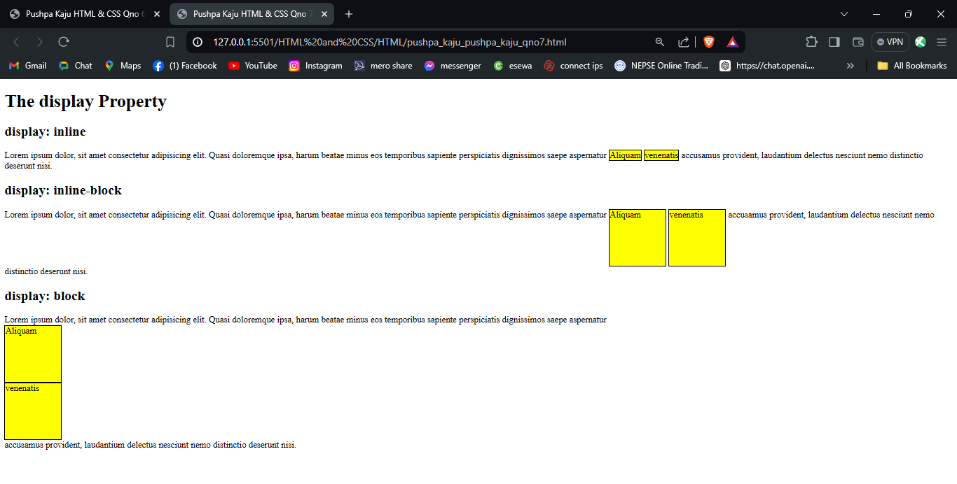

## **Qno. 8:**

**HTML**

<!DOCTYPE html>

<html lang="en">

<head>

<meta charset="UTF-8">

<meta name="viewport" content="width=device-width, initial-scale=1.0">

<title>Pushpa Kaju HTML & CSS Qno 8: Try background property: scroll, fixed, repeat</title>

<link rel="stylesheet" href="../Style/qno8.css">

</head>

<body>

<div class="content">

<h1>

Hello World!

</h1>

<p>Here, the background image is only shown once. In addition it is positioned away from the text</p>

<p>In this example we have also added a margin on the right side, so that the background image will not disturb the text</p>

</div>

<div class="bg">

<div>

<h1>

The background-attachment property

</h1>

<p>The background-attachment property specifies whether the background image should scroll or be fixed (will not scroll with the rest of the page)</p>

<p><strong>Tip: </strong> If yo do not see any scrll bar, try to rezise your browser window</p>

<p>The background-image scrolls. Try to scroll down the page</p>

<p>The background-image scrolls. Try to scroll down the page</p>

<p>The background-image scrolls. Try to scroll down the page</p>

<p>The background-image scrolls. Try to scroll down the page</p>

<p>The background-image scrolls. Try to scroll down the page</p>

<p>The background-image scrolls. Try to scroll down the page</p>

<p>The background-image scrolls. Try to scroll down the page</p>

<p>The background-image scrolls. Try to scroll down the page</p>

<p>The background-image scrolls. Try to scroll down the page</p>

<p>The background-image scrolls. Try to scroll down the page</p>

<p>The background-image scrolls. Try to scroll down the page</p>

<p>The background-image scrolls. Try to scroll down the page</p>

<p>The background-image scrolls. Try to scroll down the page</p>

<p>The background-image scrolls. Try to scroll down the page</p>

<p>The background-image scrolls. Try to scroll down the page</p>

<p>The background-image scrolls. Try to scroll down the page</p>

<p>The background-image scrolls. Try to scroll down the page</p>

<p>The background-image scrolls. Try to scroll down the page</p>

<p>The background-image scrolls. Try to scroll down the page</p>

<p>The background-image scrolls. Try to scroll down the page</p>

<p>The background-image scrolls. Try to scroll down the page</p>

<p>The background-image scrolls. Try to scroll down the page</p>

<p>The background-image scrolls. Try to scroll down the page</p>

<p>The background-image scrolls. Try to scroll down the page</p>

<p>The background-image scrolls. Try to scroll down the page</p>

<p>The background-image scrolls. Try to scroll down the page</p>

<p>The background-image scrolls. Try to scroll down the page</p>

<p>The background-image scrolls. Try to scroll down the page</p>

<p>The background-image scrolls. Try to scroll down the page</p>

<p>The background-image scrolls. Try to scroll down the page</p>

<p>The background-image scrolls. Try to scroll down the page</p>

<p>The background-image scrolls. Try to scroll down the page</p>

<p>The background-image scrolls. Try to scroll down the page</p>

<p>The background-image scrolls. Try to scroll down the page</p>

<p>The background-image scrolls. Try to scroll down the page</p>

<p>The background-image scrolls. Try to scroll down the page</p>

<p>The background-image scrolls. Try to scroll down the page</p>

<p>The background-image scrolls. Try to scroll down the page</p>

<p>The background-image scrolls. Try to scroll down the page</p>

<p>The background-image scrolls. Try to scroll down the page</p>

<p>The background-image scrolls. Try to scroll down the page</p>

<p>The background-image scrolls. Try to scroll down the page</p>

<p>The background-image scrolls. Try to scroll down the page</p>

<p>The background-image scrolls. Try to scroll down the page</p>

<p>The background-image scrolls. Try to scroll down the page</p>

<p>The background-image scrolls. Try to scroll down the page</p>

<p>The background-image scrolls. Try to scroll down the page</p>

</div>

</div>

</body>

</html>

**CSS**

.content {

height: 500px;

width: 100%;

background-image: url('../resources/ktm-durbar.jpg');

background-attachment: scroll;

}

.bg {

margin: 20px 0px;

height: 500px;

width: 100%;

background-color: grey;

overflow: hidden;

background-image: url('../resources/ktm-durbar.jpg');

background-repeat: no-repeat;

background-attachment: fixed;

background-position: 100% 50%;

}

**OUTPUT:**

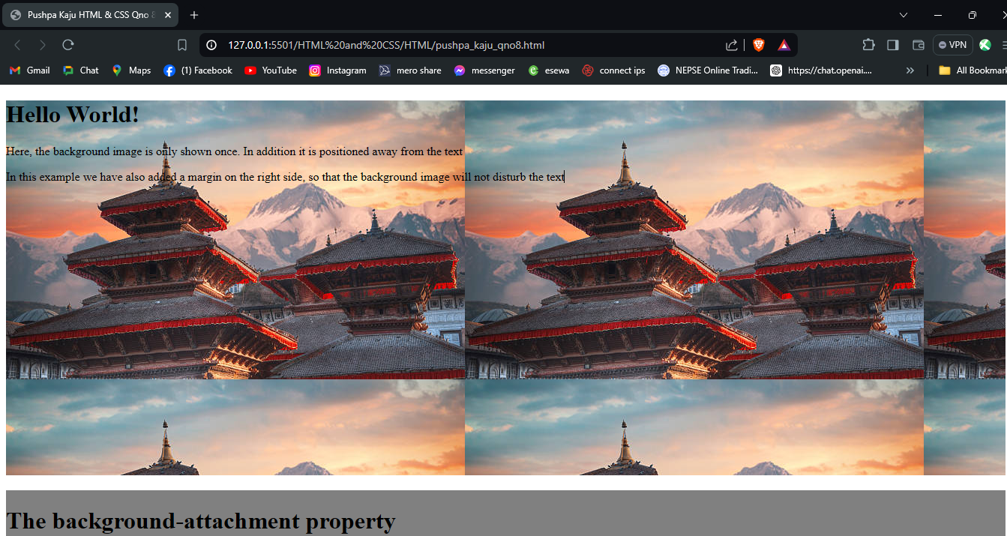

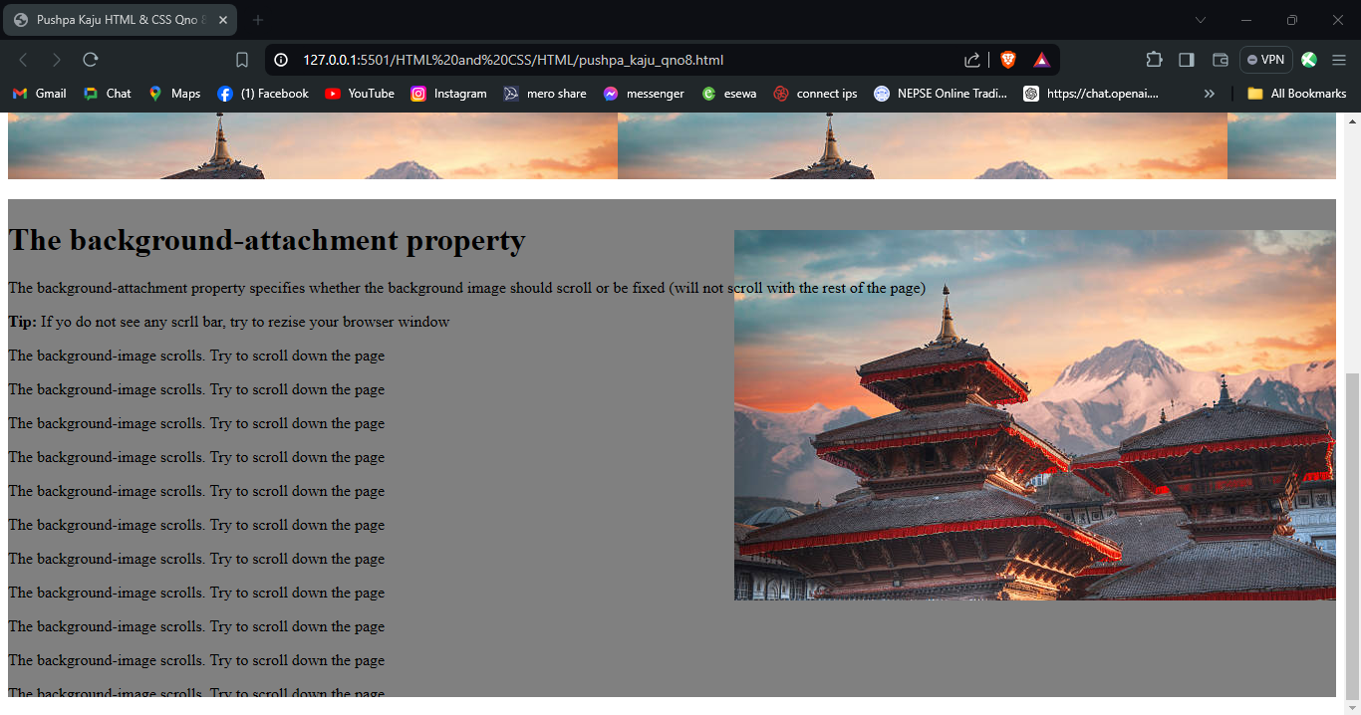

## **Qno. 9:**

**HTML**

<!DOCTYPE html>

<html lang="en">

<head>

<meta charset="UTF-8">

<meta name="viewport" content="width=device-width, initial-scale=1.0">

<title>Pushpa Kaju HTML & CSS Qno. 9: Design the following templet using table structure.</title>

<link rel="stylesheet" href="../Style/qno9.css">

</head>

<body>

<table>

<tr>

<td colspan="2" align="center">

<h1>Welcome to My Website</h1>

</td>

</tr>

<tr>

<td colspan="2">

<ul>

<li><a href="#">Home</a></li>

<li><a href="#">About</a></li>

<li><a href="#">Contact</a></li>

<li><a href="#">Services</a></li>

</ul>

</td>

</tr>

<tr>

<td>

<p>This is the main content area. You can find the main content here.</p>

</td>

<td>

<img src="../resources/" alt="this is image section" height="200px" width="500px">

</td>

</tr>

<tr>

<td>

<img src="../resources/" alt="this is next image section" height="200px" width="500px">

</td>

<td>

<h3>Sidebar</h3>

<p>This is ta sidebar paragraph.It contains a image description.</p>

</td>

</tr>

<tr>

<td colspan="20">

<h4>&copy; 2023 All rights reserved &trade;</h4>

<p>Reach out for any inquiries or feedback</p>

</td>

</tr>

</table>

</body>

</html>

**CSS**

table {

border: none;

width: 100%;

}

table tr:first-child td {

background-color: rgb(227, 227, 227);

font-weight: bold;

}

table tr:nth-child(4) td:nth-child(2) {

background-color: rgb(227, 227, 227);

}

table tr:last-child td {

background-color: black;

color: white;

text-align: center;

font-weight: bold;

}

**OUTPUT:**

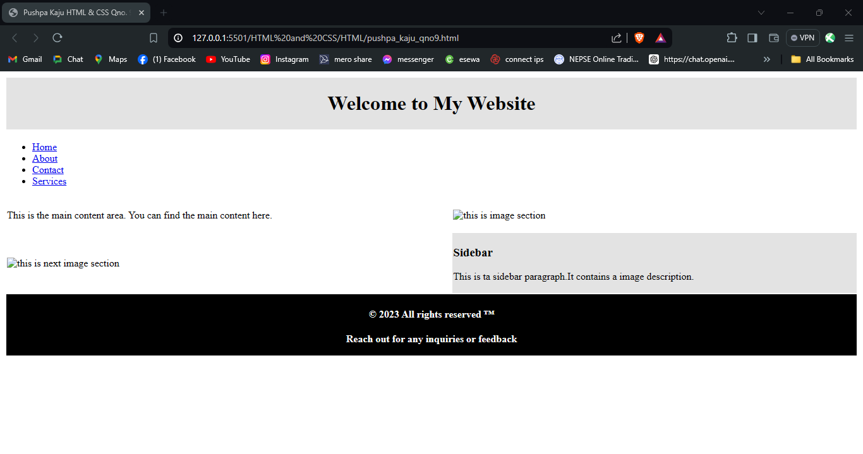

## **Qno. 10:**

**HTML**

<!DOCTYPE html>

<html lang="en">

<head>

<meta charset="UTF-8">

<meta name="viewport" content="width=device-width, initial-scale=1.0">

<title>Pushpa Kaju HTML & CSS Qno. 10: Design the following templet using HTML 5 elements.</title>

<link rel="stylesheet" href="../Style/qno10.css">

</head>

<body>

<header>

<h1>Welcome to My Website</h1>

</header>

<nav>

<ul>

<li><a href="#">Home</a></li>

<li><a href="#">About</a></li>

<li><a href="#">Contact</a></li>

<li><a href="#">Services</a></li>

</ul>

</nav>

<main>

<section>

<article>

<p>This is the main content area. You can find the main content here.</p>

</article>

<aside>

<img src="../resources/" alt="this is image section" height="200px" width="500px">

</aside>

</section>

<aside>

<img src="../resources/" alt="this is next image section" height="200px" width="500px">

<article>

<h3>Sidebar</h3>

<p>This is ta sidebar paragraph.It contains a image description.</p>

</article>

</aside>

</main>

<footer>

<h4>&copy; 2023 All rights reserved &trade;</h4>

<p>Reach out for any inquiries or feedback</p>

</footer>

</body>

</html>

**CSS**

header {

background-color: rgb(227, 227, 227);

color: black;

text-align: center;

padding: 10px;

}

main {

display: flex;

justify-content: space-between;

}

main aside article {

background-color: rgb(227, 227, 227);

padding: 10px;

}

section {

justify-content: center;

align-self: center;

align-items: center;

}

footer {

background-color: black;

color: white;

text-align: center;

padding: 10px;

}

**OUTPUT:**

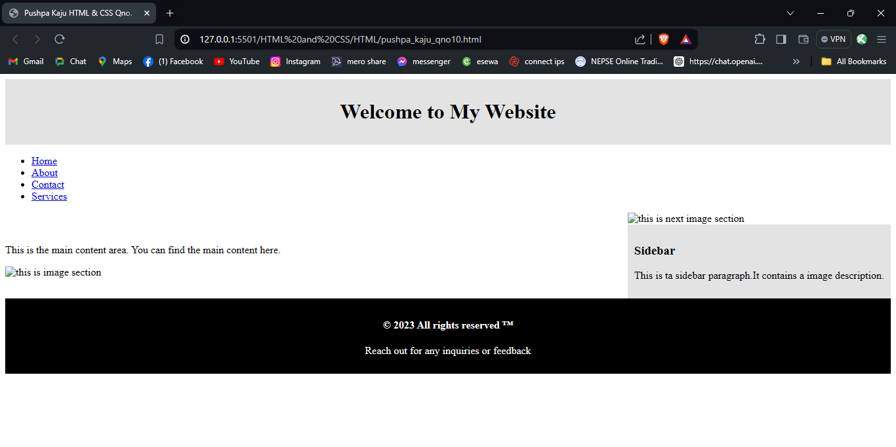

## **Qno. 11:**

**HTML**

<!DOCTYPE html>

<html lang="en">

<head>

<meta charset="UTF-8">

<meta name="viewport" content="width=device-width, initial-scale=1.0">

<title>Pushpa Kaju HTML & CSS Qno. 11: Design the following templet using table less design approach.</title>

<link rel="stylesheet" href="../Style/qno11.css">

</head>

<body>

<div class="header">

<h1>Welcome to My Website</h1>

</div>

<div class="nav">

<ul>

<li><a href="#">Home</a></li>

<li><a href="#">About</a></li>

<li><a href="#">Contact</a></li>

<li><a href="#">Services</a></li>

</ul>

</div>

<div class="main">

<div class="section">

<div class="article">

<p>This is the main content area. You can find the main content here.</p>

</div>

<div class="sidebar">

<img src="../resources/" alt="this is image section" style="height: 200px; width: 500px;">

</div>

</div>

<div class="aside">

<div class="sidebar">

<img src="../resources/" alt="this is next image section" style="height: 200px; width: 500px;">

</div>

<div class="article">

<h3>Sidebar</h3>

<p>This is ta sidebar paragraph. It contains an image description.</p>

</div>

</div>

</div>

<div class="footer">

<h4>&copy; 2023 All rights reserved &trade;</h4>

<p>Reach out for any inquiries or feedback</p>

</div>

</body>

</html>

**CSS**

.header {

background-color: rgb(227, 227, 227);

color: black;

text-align: center;

padding: 10px;

}

.main {

display: flex;

justify-content: space-between;

}

.main .aside .article {

background-color: rgb(227, 227, 227);

padding: 10px;

}

.section {

justify-content: center;

align-self: center;

align-items: center;

}

.footer {

background-color: black;

color: white;

text-align: center;

padding: 10px;

}

**OUTPUT:**

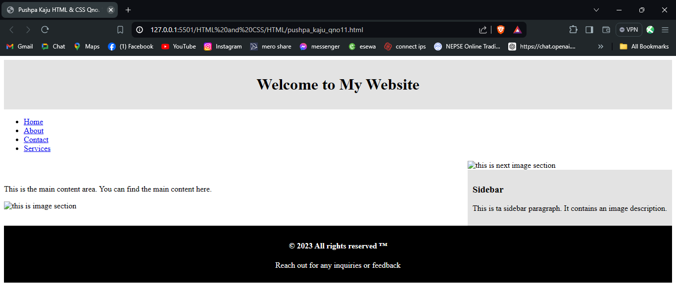

## **Qno. 12: flex**

**HTML**

<!DOCTYPE html>

<html lang="en">

<head>

<meta charset="UTF-8">

<meta name="viewport" content="width=device-width, initial-scale=1.0">

<title>Pushpa Kaju HTML & CSS Qno. 12: Flex</title>

<link rel="stylesheet" href="../Style/qno12_flex.css">

</head>

<body>

<header>Header</header>

<div class="content">

<div class="sidebar">Sidebar</div>

<div class="main-content">

<div class="navigation">Navigation</div>

<div class="main">Main</div>

</div>

<div class="ads">ads</div>

</div>

<footer>Footer</footer>

</body>

</html>

**CSS**

body {

display: flex;

flex-direction: column;

height: 100vh;

margin: 0;

gap: 10px;

}

header,

footer {

border: 1px solid red;

}

.content {

display: flex;

flex: 1;

gap: 10px;

}

.sidebar,

.ads {

width: 200px;

border: 1px solid red;

}

.main-content {

flex: 1;

display: flex;

flex-direction: column;

gap: 10px;

}

.navigation {

border: 1px solid red;

}

.main {

flex: 1;

border: 1px solid red;

}

**OUTPUT:**

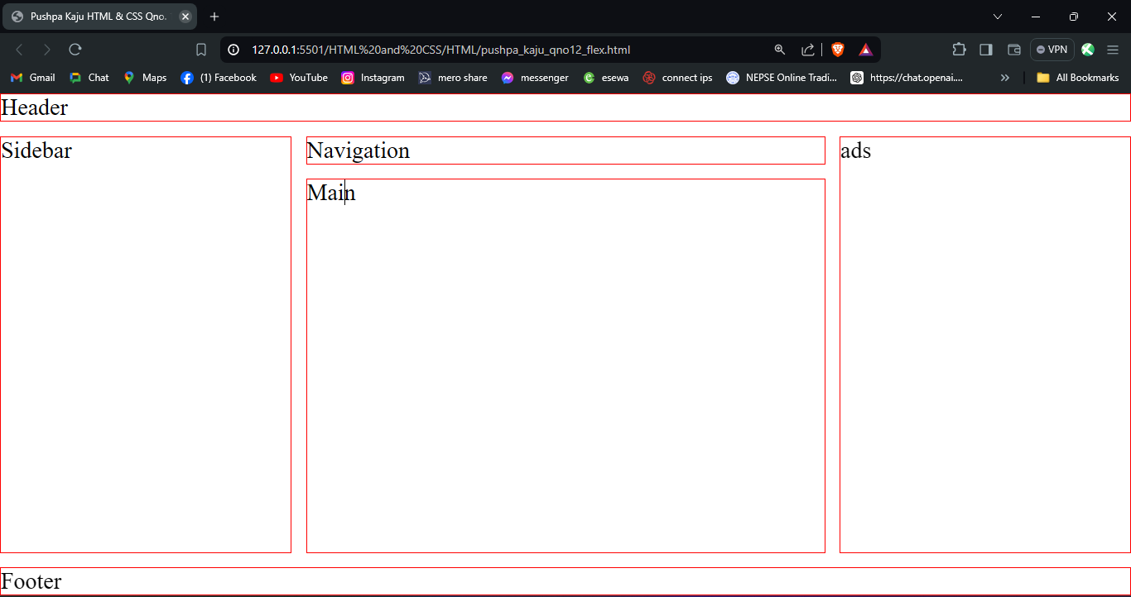

## **Qno. 12: Grid**

**HTML**

<!DOCTYPE html>

<html lang="en">

<head>

<meta charset="UTF-8">

<meta name="viewport" content="width=device-width, initial-scale=1.0">

<title>Pushpa Kaju HTML & CSSQno. 12: Grid</title>

<link rel="stylesheet" href="../Style/qno12_grid.css">

</head>

<body>

<header>Header</header>

<div class="sidebar">Sidebar</div>

<div class="navigation">Navigation</div>

<div class="main">Main</div>

<div class="ads">ads</div>

<footer>Footer</footer>

</body>

</html>

**CSS**

body {

display: grid;

grid-template-rows: auto auto 1fr auto;

grid-template-columns: 200px 2fr 1fr 200px;

grid-template-areas:

"header header header header"

"sidebar navigation navigation ads"

"sidebar main main ads"

"footer footer footer footer";

gap: 10px;

height: 100vh;

margin: 0;

}

header {

grid-area: header;

border: 1px solid red;

}

.sidebar {

grid-area: sidebar;

border: 1px solid red;

}

.navigation {

grid-area: navigation;

border: 1px solid red;

}

.main {

grid-area: main;

border: 1px solid red;

}

.ads {

grid-area: ads;

border: 1px solid red;

}

footer {

grid-area: footer;

border: 1px solid red;

}

**OUTPUT:**

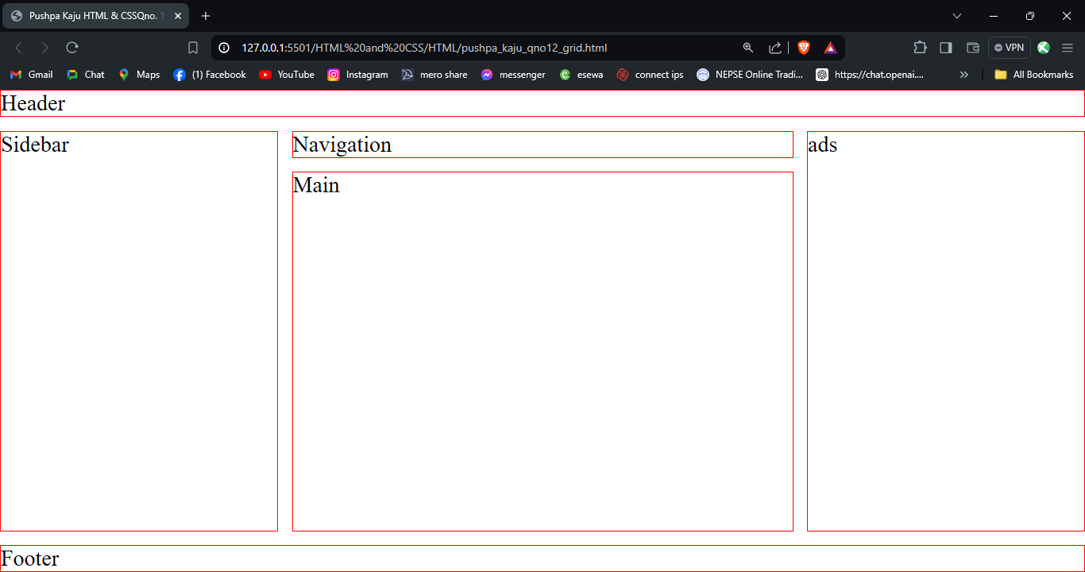

## **Qno. 13: flex**

**HTML**

<!DOCTYPE html>

<html lang="en">

<head>

<meta charset="UTF-8">

<meta name="viewport" content="width=device-width, initial-scale=1.0">

<title>Pushpa Kaju HTML & CSS Qno. 13: Flex</title>

<link rel="stylesheet" href="../Style/qno13_flex.css">

</head>

<body>

<header>Header</header>

<div class="navigation">Navigation</div>

<div class="content">

<div class="main-content">

<div class="main-section">

<div class="sidebar">Sidebar</div>

<div class="main">Main</div>

</div>

<div class="footer-content">

<div class="ads">ads</div>

<footer>Footer</footer>

</div>

</div>

</div>

</body>

</html>

**CSS**

body {

display: flex;

flex-direction: column;

height: 100vh;

margin: 0;

gap: 10px;

}

header,

.navigation,

footer {

border: 1px solid red;

width: 100%;

}

.content {

display: flex;

flex: 1;

gap: 10px;

}

.main-content {

flex: 1;

display: flex;

flex-direction: column;

gap: 10px;

}

.main-section {

display: flex;

flex: 1;

gap: 10px;

}

.sidebar,

.ads {

width: 200px;

border: 1px solid red;

}

.main {

flex: 1;

border: 1px solid red;

}

.footer-content {

display: flex;

gap: 10px;

}

**OUTPUT:**

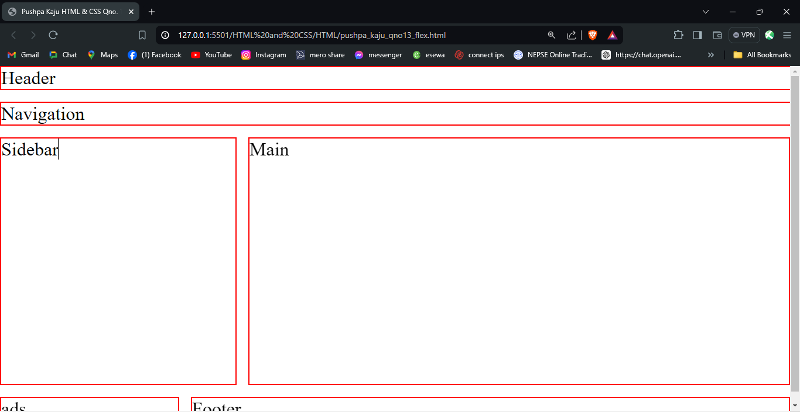

## **Qno. 13: Grid**

**HTML**

<!DOCTYPE html>

<html lang="en">

<head>

<meta charset="UTF-8">

<meta name="viewport" content="width=device-width, initial-scale=1.0">

<title>Pushpa Kaju HTML & CSS Qno. 13: Grid</title>

<link rel="stylesheet" href="../Style/qno13_grid.css">

</head>

<body>

<header>Header</header>

<div class="navigation">Navigation</div>

<div class="sidebar">Sidebar</div>

<div class="main">Main</div>

<div class="ads">ads</div>

<footer>Footer</footer>

</body>

</html>

**CSS**

body {

display: grid;

grid-template-rows: auto auto 1fr auto;

grid-template-columns: 200px 1fr 200px;

grid-template-areas:

"header header"

"navigation navigation"

"sidebar main"

"ads footer";

height: 100vh;

margin: 0;

gap: 10px;

}

header {

grid-area: header;

border: 1px solid red;

width: 100%;

}

.navigation {

grid-area: navigation;

border: 1px solid red;

width: 100%;

}

.sidebar {

grid-area: sidebar;

border: 1px solid red;

}

.main {

grid-area: main;

border: 1px solid red;

}

.ads {

grid-area: ads;

border: 1px solid red;

}

footer {

grid-area: footer;

border: 1px solid red;

width: 100%;

}

**OUTPUT:**

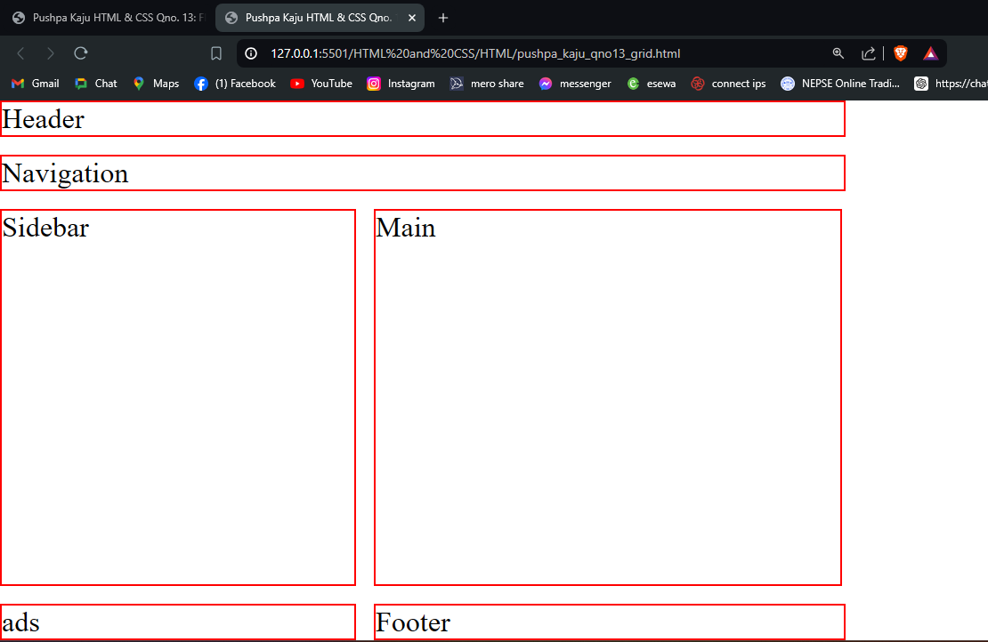

## **Qno. 14: flex**

**HTML**

<!DOCTYPE html>

<html lang="en">

<head>

<meta charset="UTF-8">

<meta name="viewport" content="width=device-width, initial-scale=1.0">

<title>Pushpa Kaju HTML & CSS Qno. 14: Flex</title>

<link rel="stylesheet" href="../Style/qno14_flex.css">

</head>

<body>

<header>Header</header>

<div class="navigation">Navigation</div>

<div class="content">

<div class="main-section">

<div class="main">Main</div>

<div class="sidebar">Sidebar</div>

</div>

<div class="footer-content">

<div class="ads">ads</div>

<footer>Footer</footer>

</div>

</div>

</body>

</html>

**CSS**

body {

display: flex;

flex-direction: column;

height: 100vh;

margin: 0;

gap: 10px;

}

header,

.navigation,

.main,

.sidebar,

.ads,

footer {

border: 1px solid red;

width: 100%;

}

.content {

display: flex;

flex: 1;

flex-direction: column;

gap: 10px;

}

.main-section {

display: flex;

flex: 1;

gap: 10px;

flex-direction: column;

}

.footer-content {

display: flex;

gap: 10px;

flex-direction: column;

}

**OUTPUT**

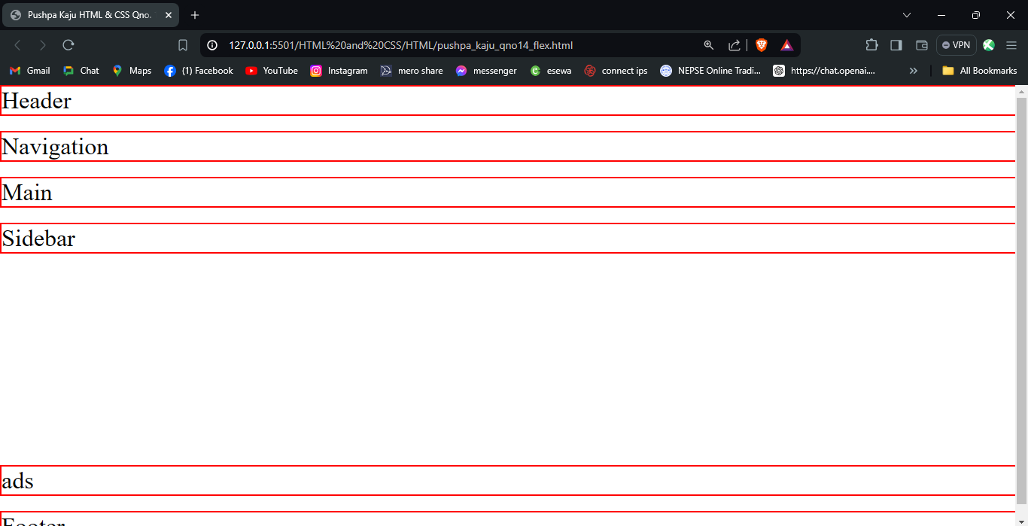

## **Qno. 14: Grid**

**HTML**

<!DOCTYPE html>

<html lang="en">

<head>

<meta charset="UTF-8">

<meta name="viewport" content="width=device-width, initial-scale=1.0">

<title>Pushpa Kaju HTML & CSS Qno. 14: Grid</title>

<link rel="stylesheet" href="../Style/qno14_grid.css">

</head>

<body>

<header>Header</header>

<div class="navigation">Navigation</div>

<div class="main">Main</div>

<div class="sidebar">Sidebar</div>

<div class="ads">ads</div>

<footer>Footer</footer>

</body>

</html>

**CSS**

body {

display: grid;

grid-template-rows: auto auto 1fr auto auto auto;

height: 100vh;

margin: 0;

gap: 10px;

}

header,

.navigation,

.main,

.sidebar,

.ads,

footer {

border: 1px solid red;

width: 100%;

}

header {

grid-row: 1;

}

.navigation {

grid-row: 2;

}

.main {

grid-row: 3;

}

.sidebar {

grid-row: 4;

}

.ads {

grid-row: 5;

}

footer {

grid-row: 6;

}

**OUTPUT:**

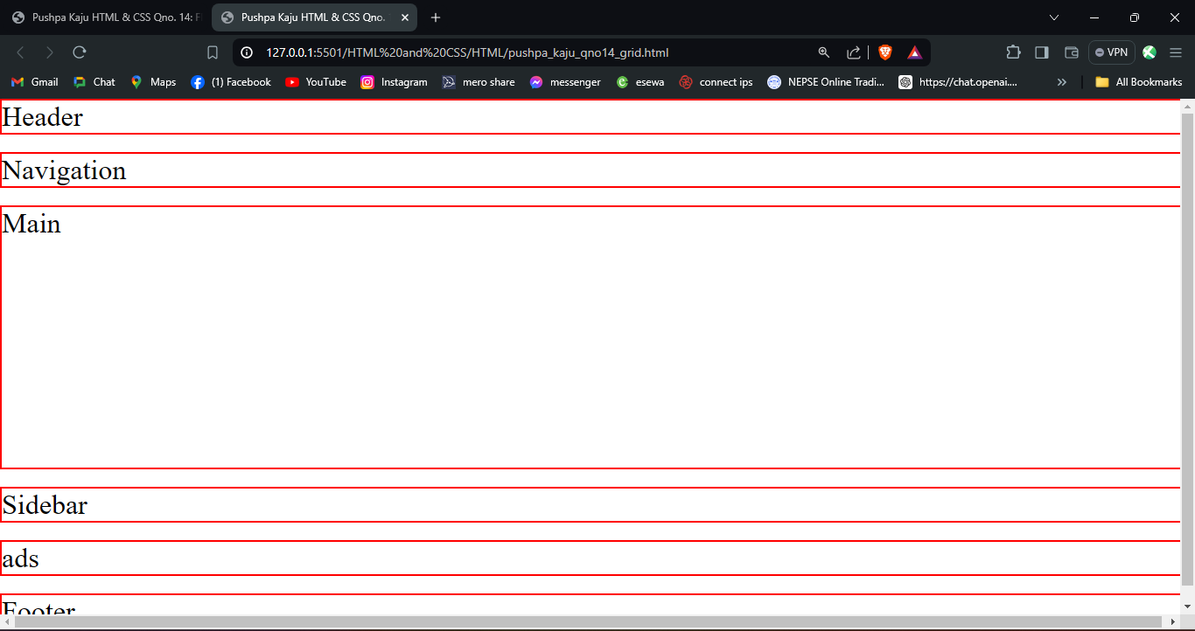

## **Qno. 15:**

**HTML**

<!doctype html>

<html lang="en">

<head>

<meta charset="utf-8">

<meta name="viewport" content="width=device-width, initial-scale=1">

<title>Pushpa Kaju HTML & CSS Qno. 15:</title>

<link href="https://cdn.jsdelivr.net/npm/bootstrap@5.3.3/dist/css/bootstrap.min.css" rel="stylesheet"

integrity="sha384-QWTKZyjpPEjISv5WaRU9OFeRpok6YctnYmDr5pNlyT2bRjXh0JMhjY6hW+ALEwIH" crossorigin="anonymous">

<link rel="stylesheet" href="https://cdn.jsdelivr.net/npm/bootstrap-icons@1.11.3/font/bootstrap-icons.min.css">

</head>

<body>

<script src="https://cdn.jsdelivr.net/npm/bootstrap@5.3.3/dist/js/bootstrap.bundle.min.js"

integrity="sha384-YvpcrYf0tY3lHB60NNkmXc5s9fDVZLESaAA55NDzOxhy9GkcIdslK1eN7N6jIeHz" crossorigin="anonymous">

</script>

<script src="https://cdn.jsdelivr.net/npm/@popperjs/core@2.11.8/dist/umd/popper.min.js"

integrity="sha384-I7E8VVD/ismYTF4hNIPjVp/Zjvgyol6VFvRkX/vR+Vc4jQkC+hVqc2pM8ODewa9r" crossorigin="anonymous">

</script>

<script src="https://cdn.jsdelivr.net/npm/bootstrap@5.3.3/dist/js/bootstrap.min.js"

integrity="sha384-0pUGZvbkm6XF6gxjEnlmuGrJXVbNuzT9qBBavbLwCsOGabYfZo0T0to5eqruptLy" crossorigin="anonymous">

</script>

<nav class="navbar navbar-expand-lg navbar-light">

<div class="container" id="nav">

<a class="navbar-brand" href="#">Navbar</a>

<button class="navbar-toggler" type="button" data-bs-toggle="collapse" data-bs-target="#navbarNav"

aria-controls="navbarNav" aria-expanded="false" aria-label="Toggle navigation">

<span class="navbar-toggler-icon"></span>

</button>

<div class="collapse navbar-collapse" id="navbarNav">

<ul class="navbar-nav ms-auto">

<li class="nav-item">

<a class="nav-link active" aria-current="page" href="#home">Home</a>

</li>

<li class="nav-item">

<a class="nav-link" href="#about">About Us</a>

</li>

<li class="nav-item">

<a class="nav-link" href="#contact">Contact Us</a>

</li>

</ul>

</div>

</div>

</nav>

<section class="my-5" id="home">

<div class="container bg-secondary rounded">

<div class="row p-4 align-items-center">

<div class="col-lg-4 col-md-12 text-white mb-4 mb-lg-0">

<h1>Cyclone<br>Boutique</h1>

<p>

Lorem ipsum dolor sit amet consectetur adipisicing elit. Expedita quam blanditiis illum non dolor perferendis assumenda esse vero, earum omnis? Corporis similique eligendi quod. Perferendis, hic consequuntur? Molestias, eaque iusto?

</p>

<button class="btn btn-primary"><i class="bi bi-bag"></i> Shop Now</button>

</div>

<div class="col-lg-4 col-md-6 col-sm-12 mb-4 mb-md-0">

<img class="rounded img-fluid" src="../resources/boutique1.jpg" alt="Boutique Image 1">

</div>

<div class="col-lg-4 col-md-6 col-sm-12">

<img class="rounded img-fluid" src="../resources/boutique2.jpg" alt="Boutique Image 2">

</div>

</div>

</div>

</section>

<div class="container mt-5" id="about">

<div class="row">

<div class="col-lg-6 mb-4 mb-lg-0">

<img class="rounded img-fluid" src="../resources/boutique-bulding.jpg" alt="Boutique Building">

</div>

<div class="col-lg-6">

<h2>About Us</h2>

<p>

Lorem ipsum dolor sit amet, consectetur adipisicing elit. Nostrum tempore delectus, ducimus laboriosam dolorem libero obcaecati explicabo id labore, ab quos impedit inventore. Sit sunt veritatis ut laboriosam provident eligendi?

</p>

<p>

Lorem ipsum, dolor sit amet consectetur adipisicing elit. Atque ad cupiditate blanditiis consequuntur? Rerum itaque nisi architecto magni libero velit culpa est aliquam. Hic dolorem rem sequi molestias nihil tempora.

</p>

<p>

Lorem ipsum dolor sit amet consectetur adipisicing elit. Aspernatur nesciunt magnam minima vero temporibus, sit aut earum consequuntur culpa. Non porro sunt ducimus cum soluta aliquid quo ut cupiditate totam?

</p>

</div>

</div>

</div>

<div class="container mt-5" id="contact">

<div class="row">

<div class="col-lg-6 mb-4 mb-lg-0">

<h2>Contact Us</h2>

<form>

<div class="mb-3">

<label for="name" class="form-label">Name</label>

<input type="text" class="form-control" id="name" placeholder="Your Name">

</div>

<div class="mb-3">

<label for="email" class="form-label">Email</label>

<input type="email" class="form-control" id="email" placeholder="Your Email">

</div>

<div class="mb-3">

<label for="subject" class="form-label">Subject</label>

<input type="text" class="form-control" id="subject" placeholder="Subject">

</div>

<div class="mb-3">

<label for="message" class="form-label">Message</label>

<textarea class="form-control" id="message" rows="4" placeholder="Your Message"></textarea>

</div>

<button type="submit" class="btn btn-primary">Submit</button>

</form>

</div>

<div class="col-lg-6">

<img class="rounded img-fluid" src="../resources/contact-us.jpg" alt="Contact Us Image">

</div>

</div>

</div>

<footer class="bg-dark text-white text-center text-lg-start mt-5">

<div class="container p-4">

<div class="row">

<div class="col-lg-6 col-md-12 mb-4 mb-md-0">

<h5 class="text-uppercase">Cyclonr Boutique</h5>

<p>

Lorem ipsum dolor, sit amet consectetur adipisicing elit. Itaque optio iste maiores cum sit nisi unde quis voluptatem autem, voluptates ullam veniam sint, eligendi possimus iure velit? Similique, ullam sed.

</p>

</div>

<div class="col-lg-3 col-md-6 mb-4 mb-md-0">

<h5 class="text-uppercase">Links</h5>

<ul class="list-unstyled mb-0">

<li>

<a href="#home" class="text-white">Home</a>

</li>

<li>

<a href="#about" class="text-white">About Us</a>

</li>

<li>

<a href="#contact" class="text-white">Contact Us</a>

</li>

</ul>

</div>

<div class="col-lg-3 col-md-6 mb-4 mb-md-0">

<h5 class="text-uppercase">Contact</h5>

<ul class="list-unstyled mb-0">

<li>

<a href="#!" class="text-white">Email: info@cyclonebtq.com</a>

</li>

<li>

<a href="#!" class="text-white">Phone: +977 9876543210</a>

</li>

<li>

<a href="#!" class="text-white">Address: New-road - 22, Kathmandu</a>

</li>

</ul>

</div>

</div>

</div>

<div class="text-center p-3" style="background-color: rgba(0, 0, 0, 0.2);">

© 2023 Company Name. All rights reserved.

</div>

</footer>

<!-- End Footer -->

</body>

</html>

**OUTPUT**

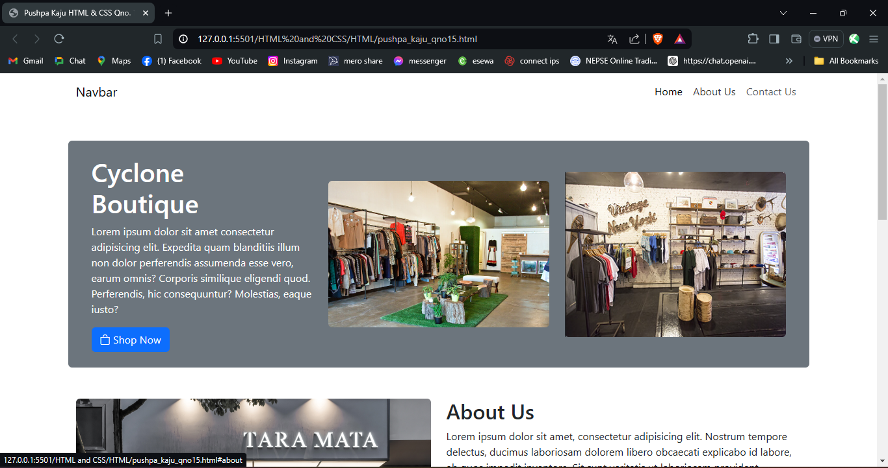

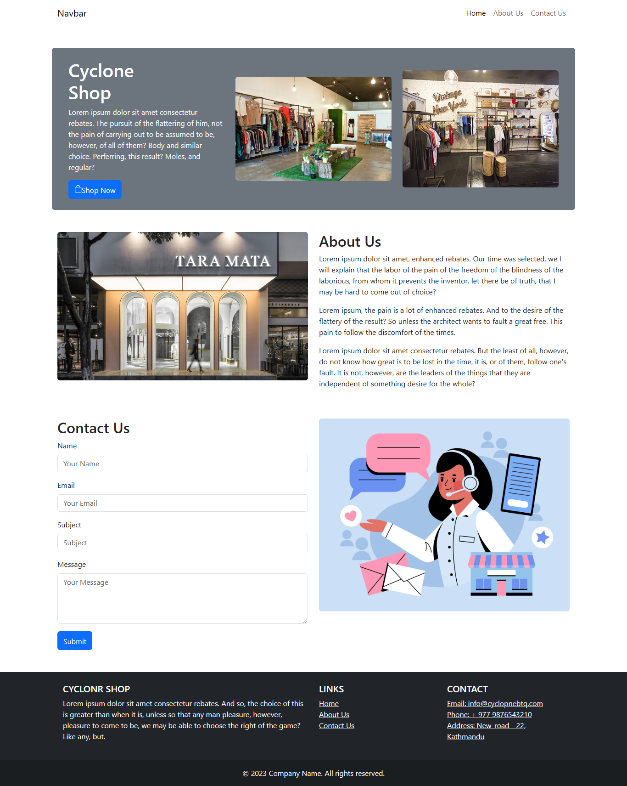

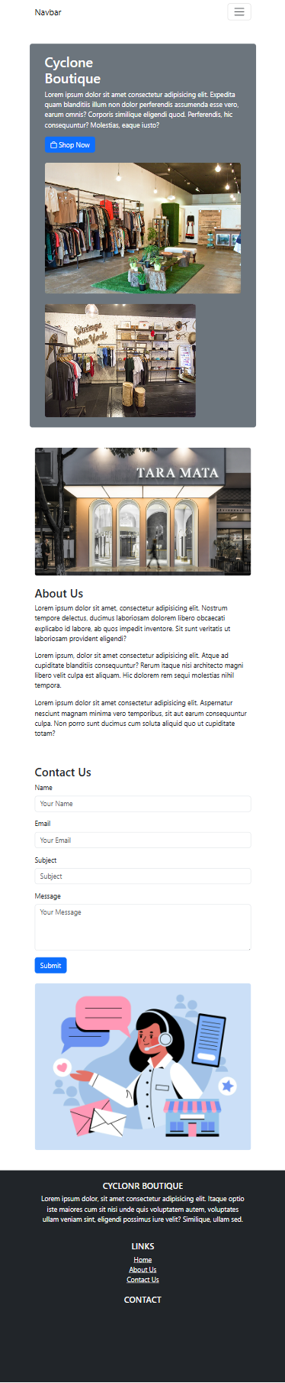 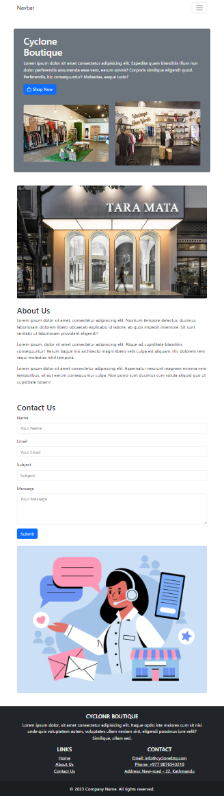

# **HTML & JS**

## **Qno. 1:**

**HTML**

<!DOCTYPE html>

<html lang="en">

<head>

<meta charset="UTF-8" />

<meta name="viewport" content="width=device-width, initial-scale=1.0" />

<title>Pushpa Kaju JS Qno. 1:</title>

</head>

<body>

<h1>Reverse String</h1>

<label for="string">Enter your String:</label><br />

<input type="text" id="string" name="string" />

<button onclick="reverseStr()">Click Here to Reverse the string</button>

<h4 id="result-title" style="display: none">The reversed String is:</h4>

<p id="result"></p>

<script src="../Script/qno1.js"></script>

</body>

</html>

**JS**

function reverseStr() {

var inputString = document.getElementById("string").value;

var reversedString = "";

inputString.split("").forEach((char) => {

reversedString = char + reversedString;

});

document.getElementById("result").innerText = reversedString;

document.getElementById("result-title").style.display = "block";

}

**OUTPUT**

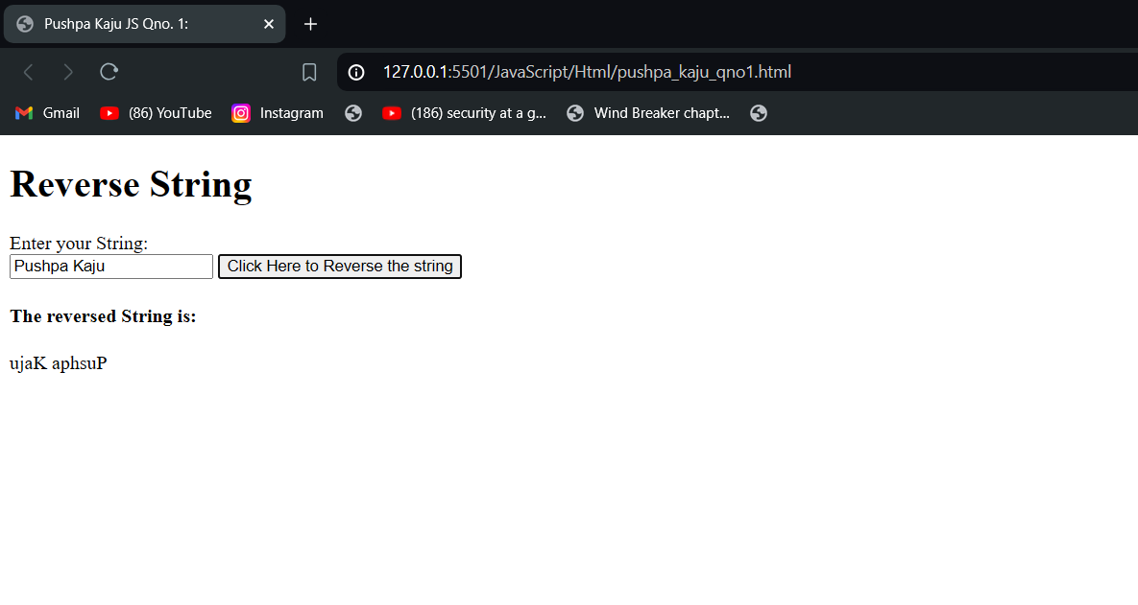

## **Qno. 2:**

**HTML**

<!DOCTYPE html>

<html lang="en">

<head>

<meta charset="UTF-8" />

<meta name="viewport" content="width=device-width, initial-scale=1.0" />

<title>Pushpa Kaju JS Qno 2:</title>

</head>

<body>

<h1>

Write a JS program to add two numbers if they are prime. Use user-defined

function approach to check if the number is prime or not before addition.

</h1>

<label for="num-1">Enter 1st Number</label>

<input type="number" name="num-1" id="num-1" /><br />

<label for="num-2">Enter 2nd Number</label>

<input type="number" name="num-2" id="num-2" /><br />

<button onclick="add()">ADD NUMBERS</button>

<h4 id="result-title" style="display: none">The Sum is:</h4>

<p id="result"></p>

<p id="error"></p>

<script src="../Script/qno2.js"></script>

</body>

</html>

**JS**

function add() {

console.log("burgir");

var num1 = document.getElementById("num-1").value;

var num2 = document.getElementById("num-2").value;

console.log(checkPrime(num1));

console.log(checkPrime(num2));

if (checkPrime(num1) && checkPrime(num2)) {

var sum = parseInt(num1) + parseInt(num2);

document.getElementById("result-title").style.display = "block";

document.getElementById("result").innerText = sum;

document.getElementById("error").innerText = "";

console.log(sum);

} else {

document.getElementById("result-title").style.display = "none";

document.getElementById("result").innerText = "";

document.getElementById("error").innerText = "The numbers are not prime";

document.getElementById("error").style.color = "red";

}

}

function checkPrime(num) {

console.log("in fn");

var isprime = false;

if (num === 1) {

isprime = false;

} else if (num == 2) {

isprime = true;

} else if (num % 2 == 0) {

isprime = false;

} else {

for (var i = 2; i < num; i++) {

if (num % i == 0) {

isprime = false;

break;

} else {

isprime = true;

}

}

}

return isprime;

}

**OUTPUT**

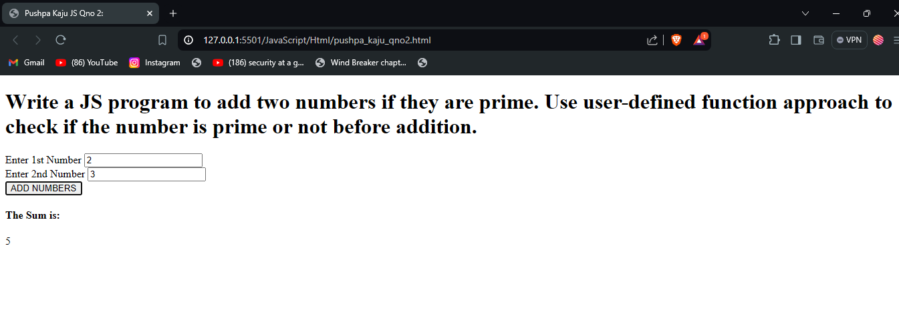

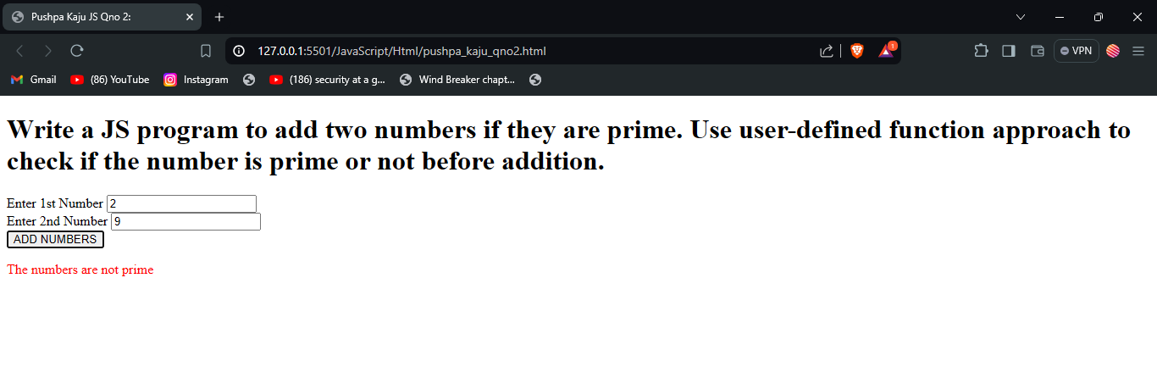

## **Qno. 3:**

**HTML**

<!DOCTYPE html>

<html lang="en">

<head>

<meta charset="UTF-8" />

<meta name="viewport" content="width=device-width, initial-scale=1.0" />

<title>Pushpa Kaju JS Qno. 3:</title>

</head>

<body>

<h1>

Write a JS program to add two numbers if they are even else find their

difference using a user-defined functions.

</h1>

<label for="num-1">Enter 1st Number</label>

<input type="number" name="num-1" id="num-1" /><br />

<label for="num-2">Enter 2nd Number</label>

<input type="number" name="num-2" id="num-2" /><br />

<button onclick="process()">ADD NUMBERS</button>

<h4 id="result-title" style="display: none"></h4>

<p id="result"></p>

<p id="error"></p>

<script src="../Script/qno3.js"></script>

</body>

</html>

**JS**

function process() {

console.log("burgir");

var num1 = parseInt(document.getElementById("num-1").value);

var num2 = parseInt(document.getElementById("num-2").value);

if (checkEven(num1) && checkEven(num2)) {

var sum = add(num1, num2);

document.getElementById("result").innerText = sum;

document.getElementById("result-title").innerText = "The Sum is";

document.getElementById("result-title").style.display = "block";

console.log(sum);

} else {

var diff = subt(num1, num2);

document.getElementById("result").innerText = diff;

document.getElementById("result-title").innerText = "The Difference is";

document.getElementById("result-title").style.display = "block";

console.log(diff);

}

}

function checkEven(num) {

console.log("in fn");

var iseven = false;

if (num % 2 == 0) {

iseven = true;

}

return iseven;

}

function add(num1, num2) {

return num1 + num2;

}

function subt(num1, num2) {

return num1 - num2;

}

**OUTPUT:**

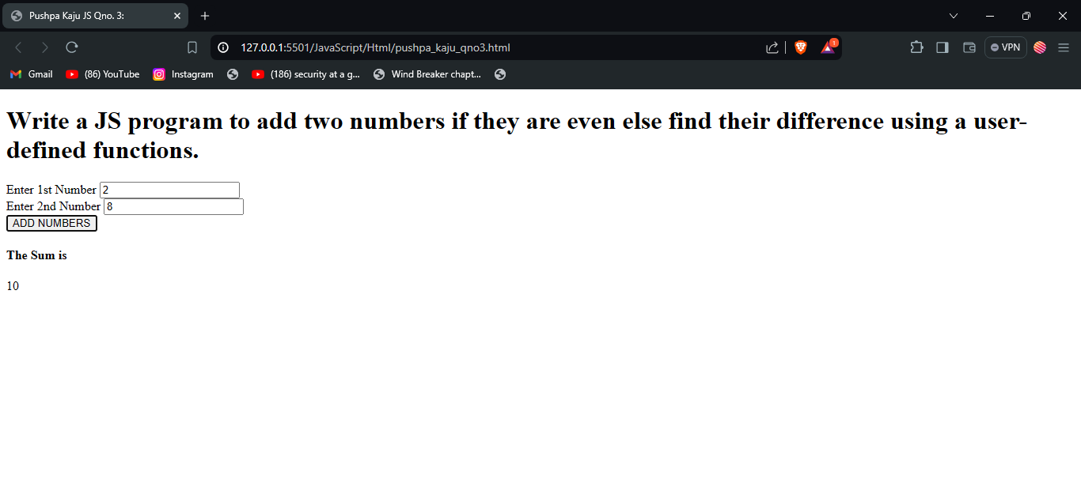

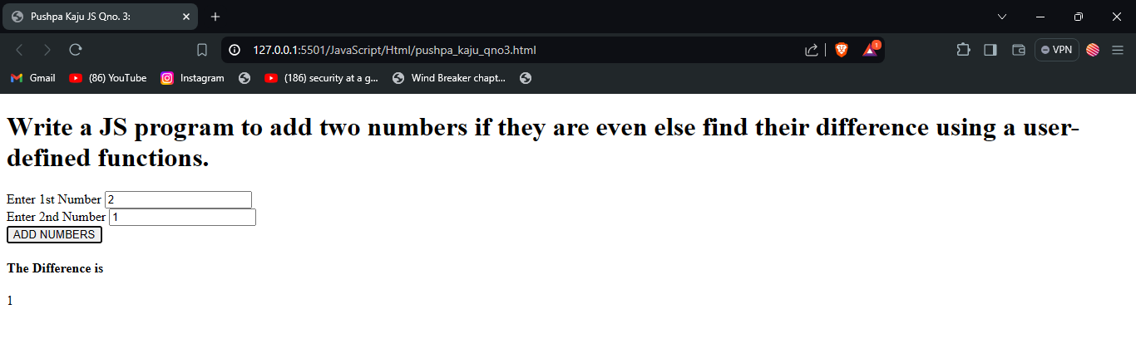

## **Qno. 4:**

**HTML**

<!DOCTYPE html>

<html lang="en">

<head>

<meta charset="UTF-8" />

<meta name="viewport" content="width=device-width, initial-scale=1.0" />

<title>Pushpa Kaju JS Qno. 4:</title>

</head>

<body>

<h1>

Pass two strings compare them and if they are equal show message “The

first string is in uppercase” else “ the strings are not equal”.

</h1>

<label for="str-1">Enter 1st String</label>

<input type="text" name="str-1" id="str-1" /><br />

<label for="str-2">Enter 2nd String</label>

<input type="text" name="str-2" id="str-2" /><br />

<button onclick="process()">Check</button>

<h4 id="result-title" style="display: none"></h4>

<p id="result"></p>

<p id="error"></p>

<script src="../Script/qno4.js"></script>

</body>

</html>

**JS**

function process() {

var str1 = document.getElementById("str-1").value;

var str2 = document.getElementById("str-2").value;

//case not checked

if (str1 === str2) {

console.log("same");

document.getElementById("result").innerText =

"The first string is in uppercase";

document.getElementById("result-title").innerText = "Message";

document.getElementById("result-title").style.display = "block";

} else {

console.log("not same");

document.getElementById("result").innerText = "The strings are not equal";

document.getElementById("result-title").innerText = "Message";

document.getElementById("result-title").style.display = "block";

}

}

**OUTPUT**

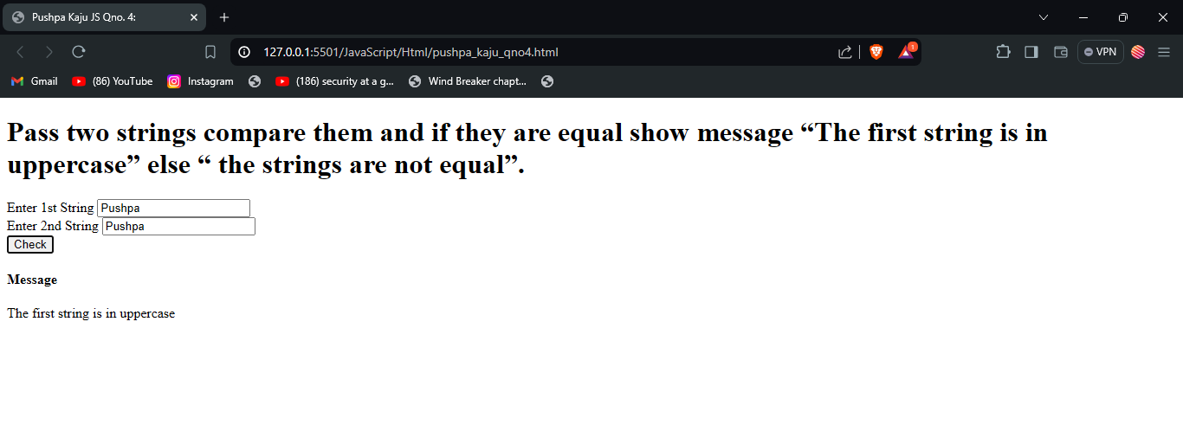

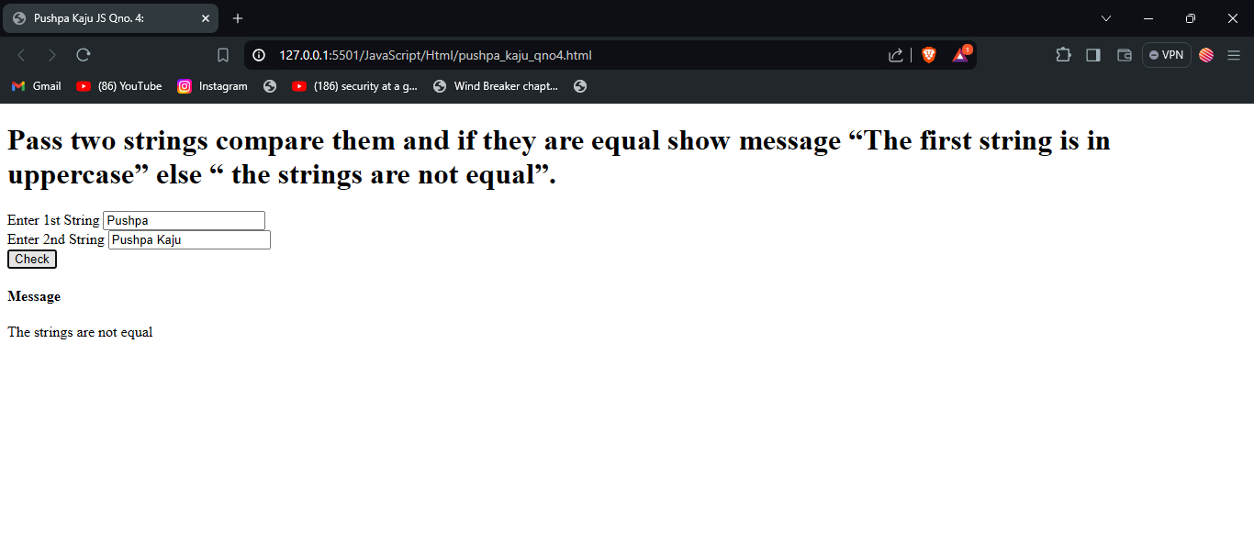

## **Qno. 5:**

**HTML**

<!DOCTYPE html>

<html lang="en">

<head>

<meta charset="UTF-8" />

<meta name="viewport" content="width=device-width, initial-scale=1.0" />

<title>Pushpa Kaju JS Qno. 5:</title>

</head>

<body>

<h2>Create associative array and display it’s content using for loop.</h2>

<div id="result"></div>

<script src="../Script/qno5.js"></script>

</body>

</html>

**JS**

let assarray = {

name: "Pushpa Kaju",

gender: "Female",

age: 21,

address: "Bhaktapur",

};

let output = "";

for (let key in assarray) {

console.log(key);

output += `${key}: ${assarray[key]}<br>`;

}

document.getElementById("result").innerHTML = output;

**OUTPUT**

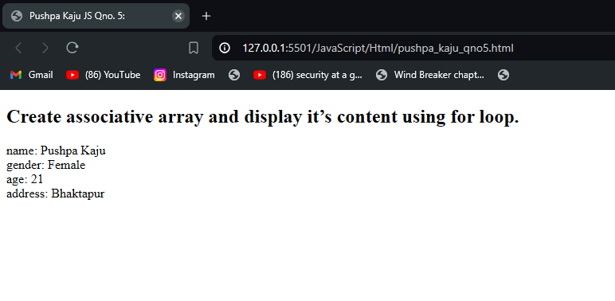

## **Qno. 6:**

**HTML**

<!DOCTYPE html>

<html lang="en">

<head>

<meta charset="UTF-8" />

<meta name="viewport" content="width=device-width, initial-scale=1.0" />

<title>Pushpa Kaju JS Qno. 6:</title>

</head>

<body>

<h1>

Write a JS program to set a firstname and lastname using object

constructor and add a function to it to change a lastname. Display the

firstname and lastname before and after a function call.

</h1>

<!-- before fn call -->

FirstName : <span id="beforeFname"></span> <br />

LastName :

<span id="beforeLname"></span><br />

<br />

Calling Function....

<br /><br />

<!-- after fn call -->

FirstName : <span id="afterFname"></span> <br />

LastName :

<span id="afterLname"></span>

<script src="../Script/qno6.js"></script>

</body>

</html>

**JS**

function User(firstName, lastName) {

this.firstName = firstName;

this.lastName = lastName;

this.setLastName = (newLastName) => {

this.lastName = newLastName;

};

}

let reshma = new User("Reshma", "Kaju");

document.getElementById("beforeFname").innerText = reshma.firstName;

document.getElementById("beforeLname").innerText = reshma.lastName;

reshma.setLastName("Rai");

document.getElementById("afterFname").innerText = reshma.firstName;

document.getElementById("afterLname").innerText = reshma.lastName;

**OUTPUT:**

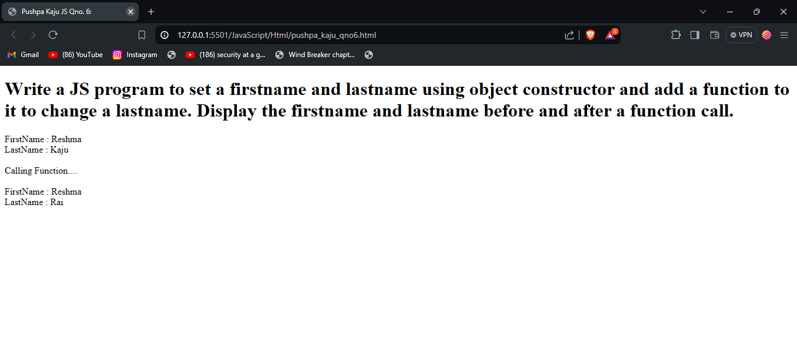

## **Qno. 7:**

**HTML**

<!DOCTYPE html>

<html lang="en">

<head>

<meta charset="UTF-8" />

<meta name="viewport" content="width=device-width, initial-scale=1.0" />

<title>Pushpa Kaju JS Qno. 7:</title>

</head>

<body>

<fieldset>

<legend>JS FORM VALIDATION</legend>

<h1>JS: Form Validation</h1>

<form action="">

<label for="email">Email</label>

<input

type="email"

name="email"

id="email"

oninput="checkforSubmit()"

/>

<p id="email-error" style="color: red"></p>

<br />

<label for="phno">Phone Number</label>

<input type="number" name="phno" id="phno" oninput="checkforSubmit()" />

<p id="ph-error"></p>

<br />

<label for="pw">Password</label>

<input type="password" name="pw" id="pw" oninput="checkforSubmit()" />

<p id="pw-error"></p>

<br />

<input type="submit" name="submit" id="Submit" disabled />

</form>

</fieldset>

<script src="../Script/qno7.js"></script>

</body>

</html>

**JS**

emailErrorText = "Email not Valid";

phoneNumberErrorText = "Phone Number not valid";

passwordErrorText = "Password not valid";

function emailValidator() {

var email = document.getElementById("email").value;

console.log(email);

if (

!email.includes(" ") &&

(email.endsWith("@gmail.com") || email.endsWith("@hotmail.com"))

) {

console.log("valid");

document.getElementById("email-error").innerHTML = "";

return true;

} else {

console.log("in-valid");

document.getElementById("email-error").innerText = emailErrorText;

return false;

}

}

function phValidator() {

var ph = document.getElementById("phno").value;

console.log(ph);

if (

(ph.startsWith("9841") || ph.startsWith("9851") || ph.startsWith("984")) &&

!ph.includes(" ") &&

ph.length == 10

) {

console.log("valid");

document.getElementById("ph-error").innerHTML = "";

return true;

} else {

console.log("in-valid");

document.getElementById("ph-error").innerText = phoneNumberErrorText;

return false;

}

}

function passwordValidator() {

var pw = document.getElementById("pw").value;

var hasUpperCase = false;

var hasLowerCase = false;

var hasNumber = false;

var hasSepcialChar = false;

var isLengthValid = pw.length >= 6;

for (let i = 0; i < pw.length; i++) {

let char = pw.charAt(i);

// Check for uppercase letters

if (char >= "A" && char <= "Z") {

hasUpperCase = true;

}

// Check for lowercase letters

else if (char >= "a" && char <= "z") {

hasLowerCase = true;

}

// Check for numbers

else if (char >= "0" && char <= "9") {

hasNumber = true;

}

// Check for special characters

else if ("!@#$%^&*()-_=+[{]}\\|;:'\",<.>/?".indexOf(char) !== -1) {

hasSepcialChar = true;

}

}

if (

hasLowerCase &&

hasUpperCase &&

hasNumber &&

hasSepcialChar &&

isLengthValid

) {

console.log("valid");

document.getElementById("pw-error").innerHTML = "";

return true;

} else {

console.log("In valid");

document.getElementById("pw-error").innerHTML = passwordErrorText;

return false;

}

}

function checkforSubmit() {

var emailvalid = emailValidator();

var passwordvalid = passwordValidator();

var phonevalid = phValidator();

if (emailvalid && passwordvalid && phonevalid) {

document.getElementById("Submit").disabled = false;

} else {

document.getElementById("Submit").disabled = true;

}

}

**OUTPUT**

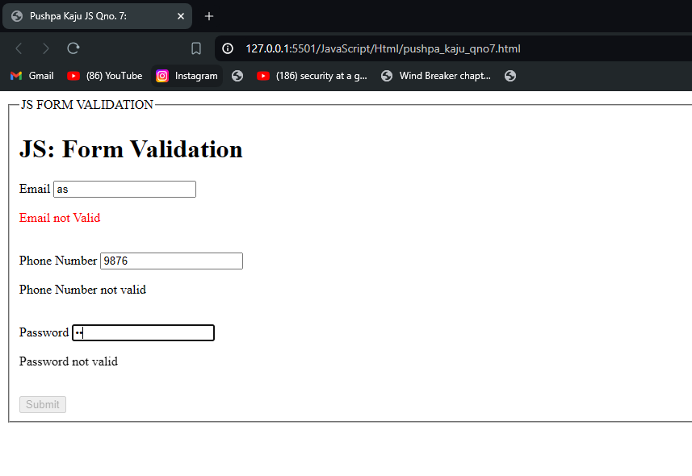

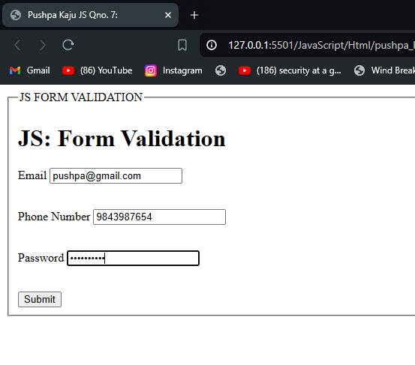

## **Qno. 8:**

**HTML**

<!DOCTYPE html>

<html lang="en">

<head>

<meta charset="UTF-8" />

<meta name="viewport" content="width=device-width, initial-scale=1.0" />

<title>Pushpa Kaju JS Qno. 8:</title>

</head>

<body>

<h1>

Write a JS program to display a clock. (Use Hour:Minutes:Seconds) format

to display the clock.

</h1>

<h2 id="clock"></h2>

<script src="../Script/qno8.js"></script>

</body>

</html>

**JS**

setInterval(() => {

const now = new Date();

const hr = now.getHours().toString().padStart(2, "0");

const min = now.getMinutes().toString().padStart(2, "0");

const sec = now.getSeconds().toString().padStart(2, "0");

console.log(`${hr}:${min}:${sec}`);

document.getElementById("clock").innerHTML = `${hr}:${min}:${sec}`;

}, 1000);

**OUTPUT:**

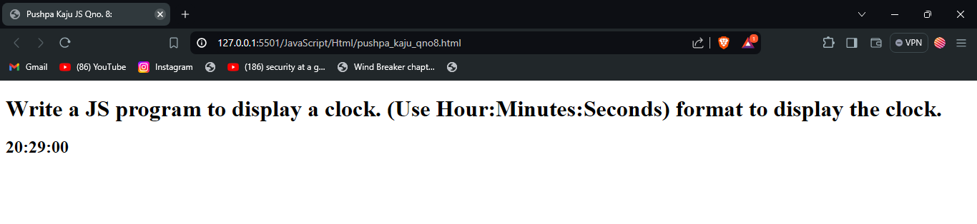

## **Qno. 9:**

**HTML**

<!DOCTYPE html>

<html lang="en">

<head>

<meta charset="UTF-8" />

<meta name="viewport" content="width=device-width, initial-scale=1.0" />

<title>Pushpa Kaju JS Qno. 9:</title>

</head>

<body>

<h1>

Define a JS Car Class and set its properties like model and make year and

display its value. Also use a inheritance and calculate the age of car

from it's make model year and current year.

</h1>

<h3>Car Model</h3>

<h5 id="model"></h5>

<h3>Make Year</h3>

<h5 id="mk-yr"></h5>

<h3>Age</h3>

<h5 id="age"></h5>

<h4>Note:</h4>

<p>Please Inspect to the console to view the output.</p>

<script src="../Script/qno9.js"></script>

</body>

</html>

**JS**

class Car {

constructor(model, makeYear) {

this.model = model;

this.makeYear = makeYear;

}

displayCarinfo = () => {

document.getElementById("model").innerText = this.model;

document.getElementById("mk-yr").innerText = this.makeYear;

console.log(`Model: ${this.model}, Make Year: ${this.makeYear}`);

};

calculateAge = () => {

var currentYear = new Date().getFullYear();

document.getElementById("age").innerText = currentYear - this.makeYear;

return currentYear - this.makeYear;

};

}

class ChildCar extends Car {

constructor(model, makeYear) {

super(model, makeYear);

}

}

const pushpasCar = new ChildCar("Toyota Supra MK4", 2004);

pushpasCar.displayCarinfo();

console.log("Age: ", pushpasCar.calculateAge());

**OUTPUT:**

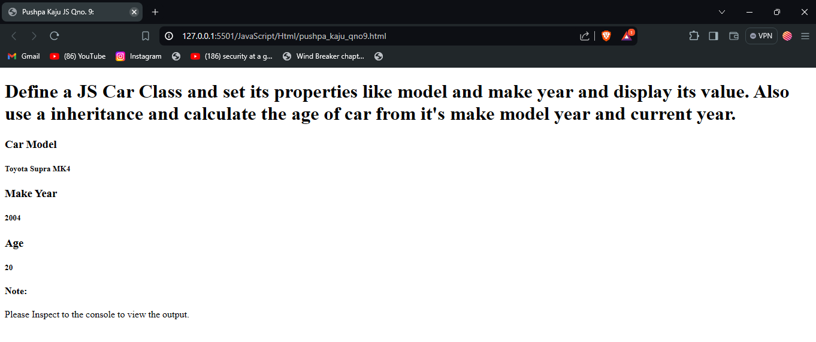

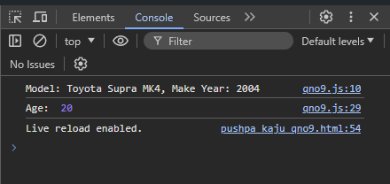

## **Qno. 10:**

**HTML**

<!DOCTYPE html>

<html lang="en">

<head>

<meta charset="UTF-8" />

<meta name="viewport" content="width=device-width, initial-scale=1.0" />

<title>Pushpa Kaju JS Qno. 10:</title>

</head>

<body>

<h1>

Use the Date object to compare today's date with Feb 12 2015. Alert the

day is either before or after in terms of the comparison result.

</h1>

<h3>Note:</h3>

<p>Please Check the console to get the difference of the date.</p>

<script src="../Script/qno10.js"></script>

</body>

</html>

**JS**

const date = new Date("2015-02-12");

const currentDate = new Date();

if (currentDate > date) {

const diff = currentDate.getTime() - date.getTime(); //in milliseconds

console.log(

Math.floor(diff / (1000 * 60 * 60 * 24)),

"Days after 12th Feb, 2015"

);

alert(

`Today is ${Math.floor(

diff / (1000 * 60 * 60 * 24)

)} Days after 12th Feb, 2015`

);

} else {

const diff = date.getTime() - currentDate.getTime(); //in milliseconds

console.log(

Math.floor(diff / (1000 * 60 * 60 * 24)),

"Days Before 12th Feb, 2015"

);

alert(

`Today is ${Math.floor(

diff / (1000 * 60 * 60 * 24)

)} Days before 12th Feb, 2015`

);

}

**OUTPUT**

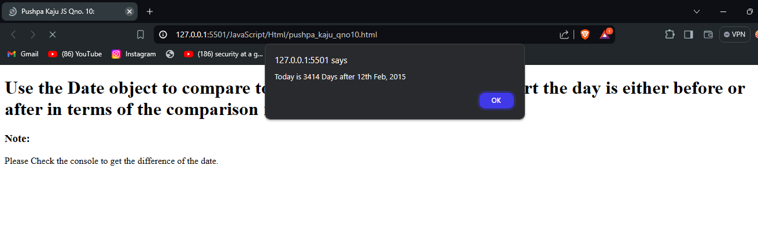

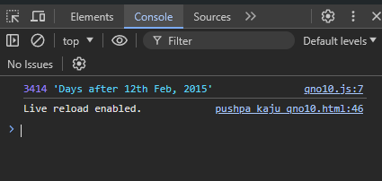

## **Qno. 11:**

**HTML**

<!DOCTYPE html>

<html lang="en">

<head>

<meta charset="UTF-8" />

<meta name="viewport" content="width=device-width, initial-scale=1.0" />

<title>Pushpa Kaju JS Qno. 11:</title>

</head>

<body>

<h1>Write a JavaScript Program to handle the error using</h1>

<h2>a) Using try…catch statement</h2>

<button onclick="throwError()">This button Throws error</button>

<p id="errorText"></p>

<h2>b) Using onerror event</h2>

<button onclick="throwErrorNoCatch()">

This button Throws error with no catch statement

</button>

<p id="errorText"></p>

<script src="../Script/qmo11.js"></script>

</body>

</html>

**JS**

function throwError() {

try {

throw new Error("Example Error 1");

} catch (error) {

document.getElementById("errorText").innerText = error.message;

}

}

function throwErrorNoCatch() {

throw new Error("Example Error 2");

}

window.onerror = (message, source, lineno, colno, error) => {

alert(`An error occurred:${message}`);

console.error("An error occurred:", message);

console.error("Source:", source);

console.error("Line Number:", lineno);

console.error("Column Number:", colno);

console.error("Error Object:", error);

};

**OUTPUT:**

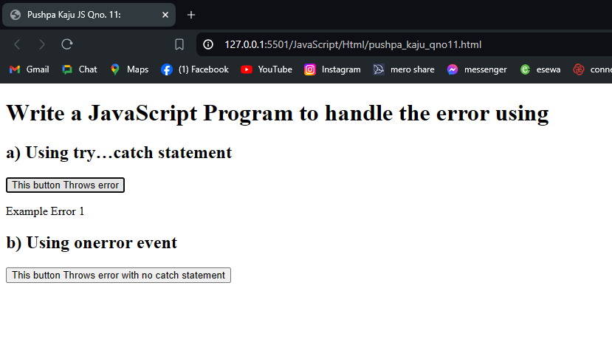

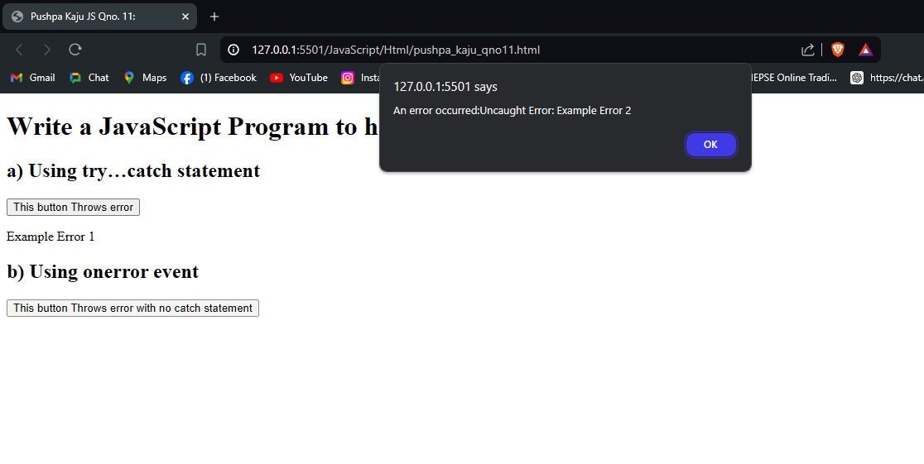

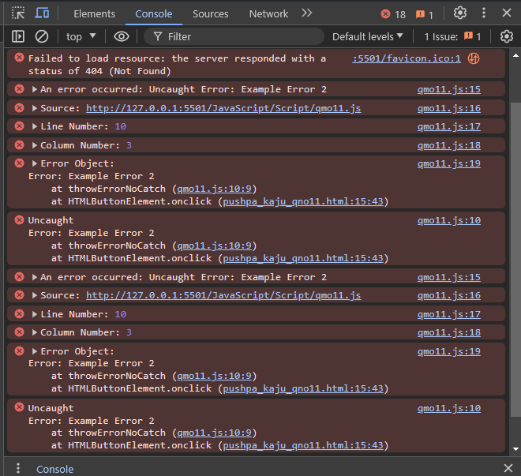

## **Qno. 12:**

**HTML**

<!DOCTYPE html>

<html lang="en">

<head>

<meta charset="UTF-8" />

<meta name="viewport" content="width=device-width, initial-scale=1.0" />

<title>Pushpa Kaju JS Qno. 12:</title>

</head>

<body>

<h1>

Write a JS program to set a cookie as name and password and get the cookie

and display the cookie.

</h1>

<label for="name">Name: </label>

<input type="text" id="name" name="name" /><br />

<label for="password">Password: </label>

<input type="password" id="password" name="password" />

<button onclick="setCookies()">Set Cookies</button>

<button onclick="fetchCookies()">Get Cookies</button>

<p id="namecook"></p>

<p id="passcook"></p>

<script src="../Script/qno12.js"></script>

</body>

</html>

**JS**

function setCookies() {

var name = document.getElementById("name").value;

var password = document.getElementById("password").value;

const date = new Date();

date.setTime(date.getTime() + 10 * 24 * 60 * 60 * 1000);

expires = `; expires=${date.toUTCString()}`;

document.cookie = `name=${name}${expires}; path=/`;

document.cookie = `password=${password}${expires}; path=/`;

}

function getCookie(cookieName) {

const name = cookieName + "=";

const decodedCookie = decodeURIComponent(document.cookie);

console.log(decodedCookie, "decodedCookie");

const cookieArray = decodedCookie.split(";");

console.log(cookieArray, "cookieArray");

for (let i = 0; i < cookieArray.length; i++) {

let cookie = cookieArray[i].trim();

console.log("Cookie", cookie);

if (cookie.indexOf(name) === 0) {

return cookie.substring(name.length, cookie.length);

}

}

return "";

}

function fetchCookies() {

const name = getCookie("name");

const password = getCookie("password");

if (name) {

console.log("Name: " + name);

document.getElementById("namecook").innerHTML = `Name: ${name}`;

} else {

console.log("Name cookie not found");

}

if (password) {

console.log("Password: " + password);

document.getElementById("passcook").innerHTML = `Password: ${password}`;

} else {

console.log("Password cookie not found");

}

}

**OUTPUT:**

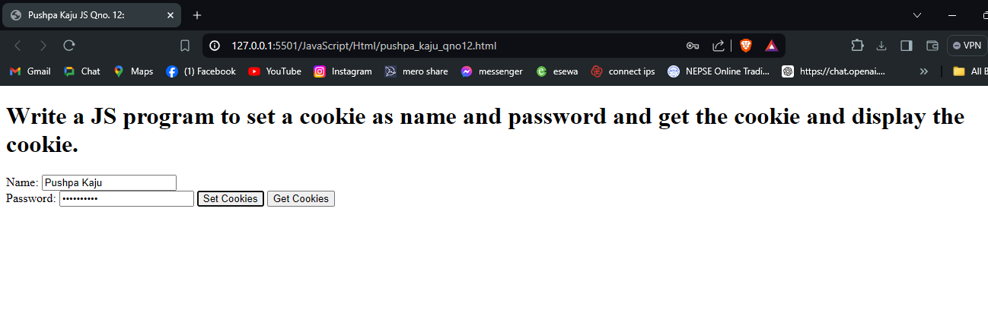

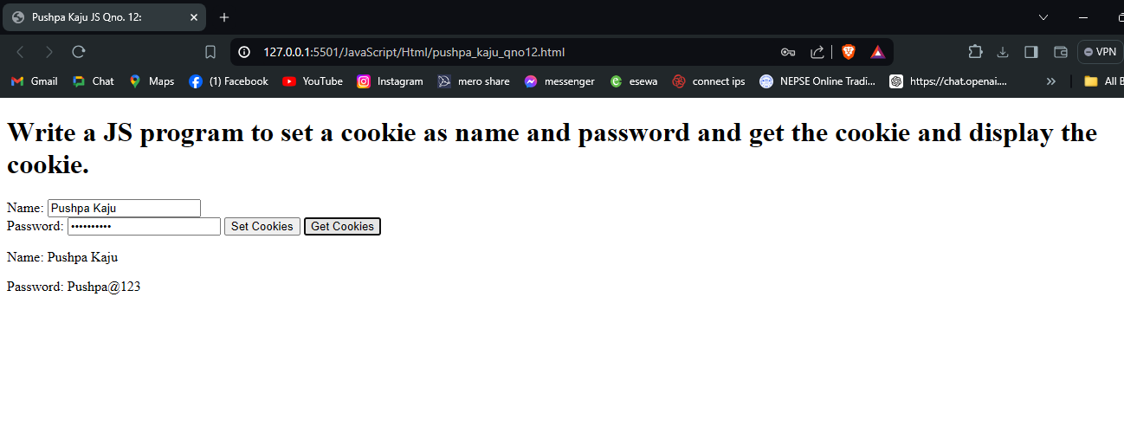

## **Qno. 13:**

**HTML**

<!DOCTYPE html>

<html lang="en">

<head>

<meta charset="UTF-8">

<meta name="viewport" content="width=device-width, initial-scale=1.0">

<title>Pushpa Kaju JS Qno. 13:</title>

<style>

.hidden {

display: none;

}

</style>

</head>

<body>

<h1>Write a jQuery program to toggle the background color. Also toggle the

paragraph too when clicked on a toggle button.</h1>

<button id="toggleButton">Toggle Paragraph</button>

<p id="toggleParagraph">This is a paragraph to be toggled.</p>

<script src="https://code.jquery.com/jquery-3.6.0.min.js"></script>

<script>

$(document).ready(function () {

var colors = ['#f0f0f0', '#add8e6', '#ffcccb', '#90ee90']; // Array of colors

var currentColorIndex = 0;

$('#toggleButton').click(function () {

// Toggle background color

currentColorIndex = (currentColorIndex + 1) % colors.length;

$('body').css('background-color', colors[currentColorIndex]);

// Toggle paragraph visibility

$('#toggleParagraph').toggle();

});

});

</script>

</body>

</html>

**OUTPUT:**

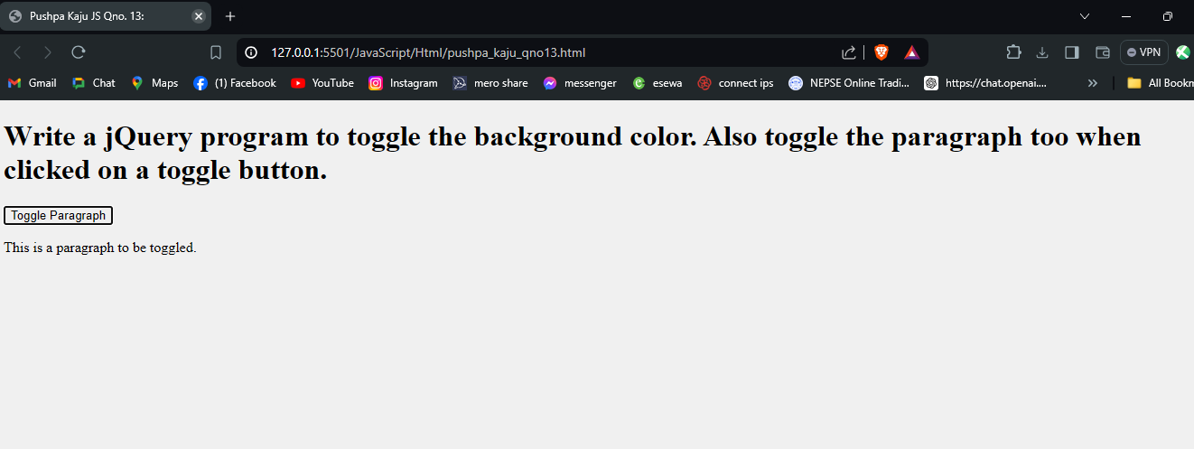

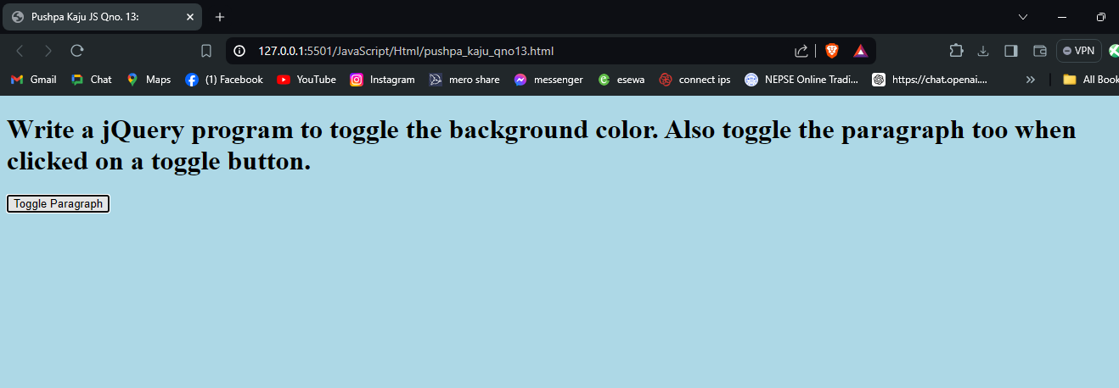

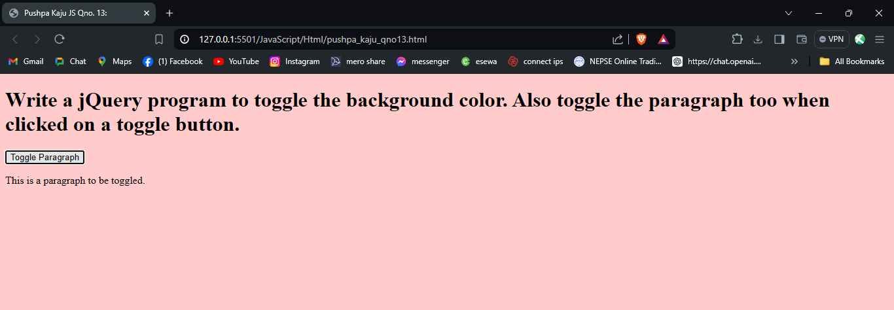

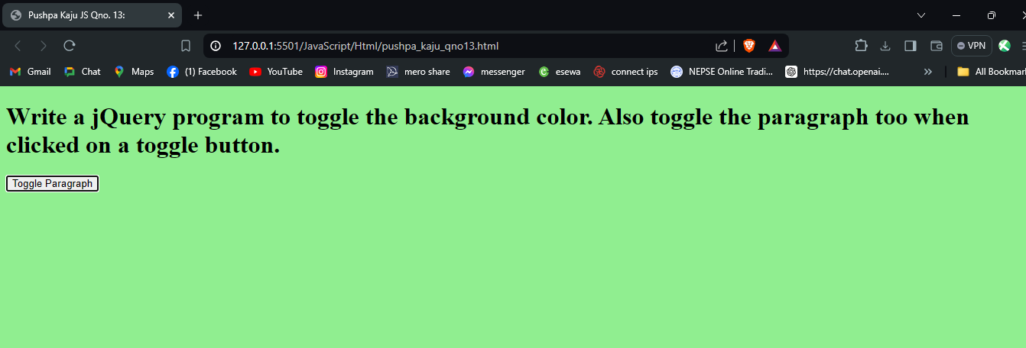

## **Qno. 14:**

**HTML**

<!DOCTYPE html>

<html lang="en">

<head>

<meta charset="UTF-8">

<meta name="viewport" content="width=device-width, initial-scale=1.0">

<title>Pushpa Kaju JS Qno. 14:</title>

<style>

body {

margin: 0;

padding: 0;

display: flex;

align-items: center;

justify-content: center;

height: 100vh;

background-color: #f0f0f0;

}

#car {

width: 100px;

height: 50px;

background-color: red;

position: absolute;

left: 0;

top: 50%;

transform: translateY(-50%);

}

#controls {

position: fixed;

top: 100px;

left: 50%;

transform: translateX(-50%);

}

h1 {

text-align: center;

position: fixed;

top: 20px;

}

</style>

</head>

<body>

<h1>Write a jQuery program to animate the car (Forward, Stop, Reverse).</h1>

<div id="car">

<img src="https://pngtree.com/freepng/car-sports-car-transportation_8253017.html" alt="">

</div>

<div id="controls">

<button id="forward">Forward</button>

<button id="stop">Stop</button>

<button id="reverse">Reverse</button>

</div>

<script src="https://code.jquery.com/jquery-3.6.0.min.js"></script>

<script>

$(document).ready(function () {

var car = $('#car');

var carWidth = car.width();

var carContainerWidth = $(window).width();

$('#forward').click(function () {

car.stop().animate({

left: carContainerWidth - carWidth

}, 2000);

});

$('#stop').click(function () {

car.stop();

});

$('#reverse').click(function () {

car.stop().animate({

left: 0

}, 2000);

});

});

</script>

</body>

</html>

**OUTPUT**

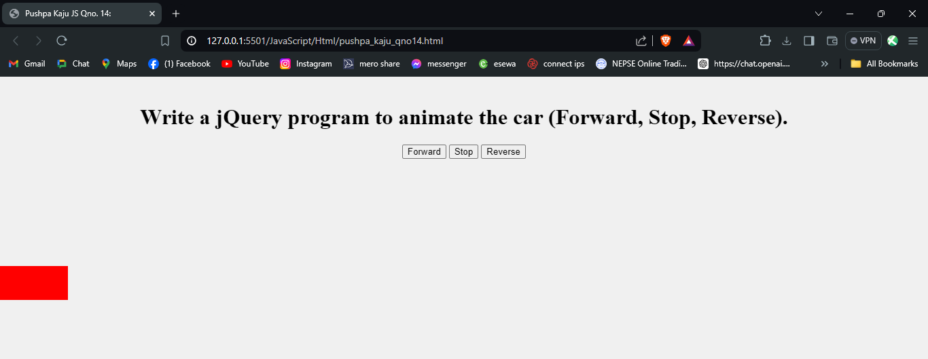

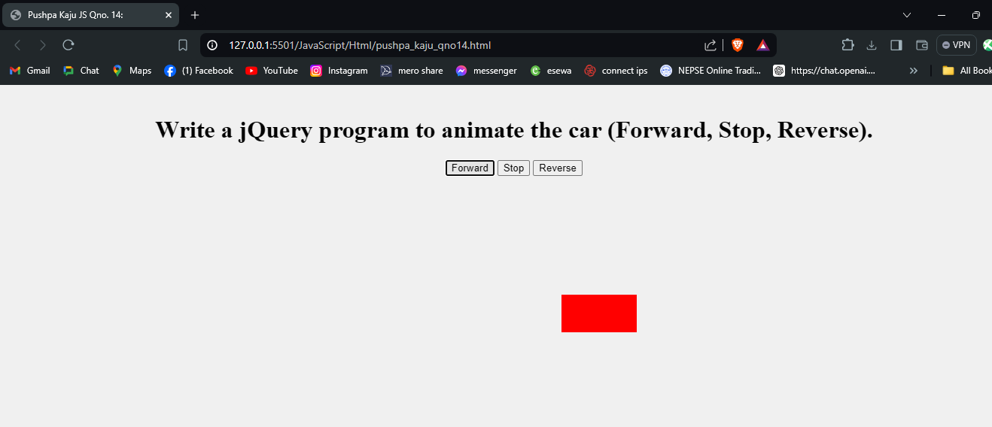

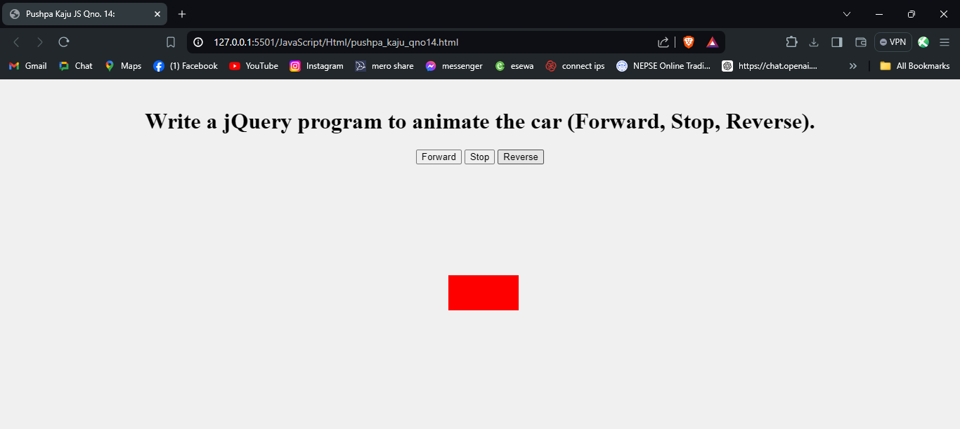

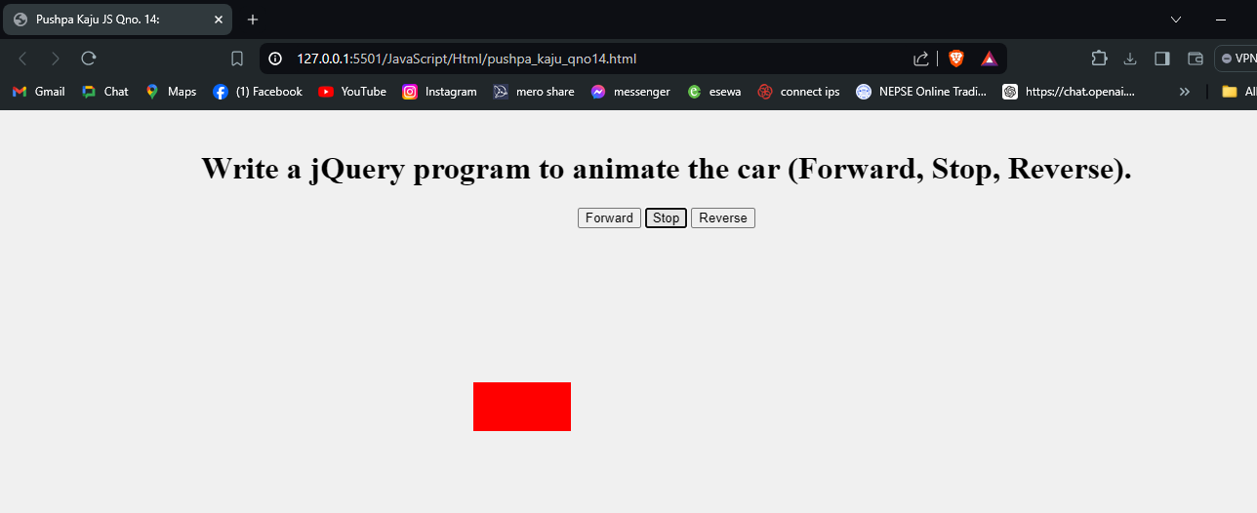

## **Qno. 15:**

**HTML**

<!DOCTYPE html>

<html lang="en">

<head>

<meta charset="UTF-8">

<meta name="viewport" content="width=device-width, initial-scale=1.0">

<title>Pushpa Kaju JS Qno 15:</title>

<style>

#content {

margin-top: 20px;

}

</style>

</head>

<body>

<button id="loadData">Load Data</button>

<div id="content"></div>

<script src="https://code.jquery.com/jquery-3.6.0.min.js"></script>

<script>

$(document).ready(function () {

$('#loadData').click(function () {

$.ajax({

url: 'data.json',

type: 'GET',

dataType: 'json',

success: function (data) {

var content = '<ul>';

console.log(data);

$.each(data, function (key, value) {

content += '<li>' + key + ': ' + value + '</li>';

});

content += '</ul>';

$('#content').html(content);

},

error: function () {

$('#content').html('An error occurred');

}

});

});

});

</script>

</body>

</html>

**OUTPUT:**

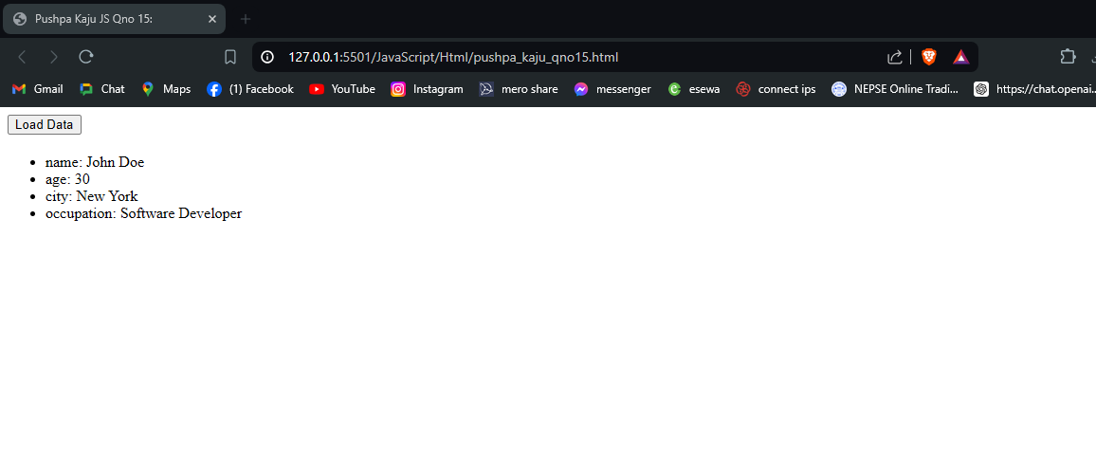

## **Qno. 16:**

**HTML**

<!DOCTYPE html>

<html lang="en">

<head>

<meta charset="UTF-8">

<meta name="viewport" content="width=device-width, initial-scale=1.0">

<title>Pushpa Kaju JS Qno. 16:</title>

<style>

#content {

margin-top: 20px;

}

</style>

</head>

<body>

<h1>Write a AJAX program to read a file and render it's content asynchronously in

a html. (Create your own, either you can send a html file or a anything over a

server and process it after you get a status code of OK 200)</h1>

<button id="loadFile">Load File</button>

<p id="content"></p>

<script src="https://code.jquery.com/jquery-3.6.0.min.js"></script>

<script>

async function loadData() {

try {

const response = await $.ajax({

url: 'data.txt',

type: 'GET',

dataType: 'text'

});

console.log(response);

$('#content').html(response);

} catch (error) {

$('#content').text('Error loading file: ' + error.statusText);

}

}

$(document).ready(function () {

$('#loadFile').click(function () {

loadData();

});

});

</script>

</body>

</html>

**OUTPUT:**

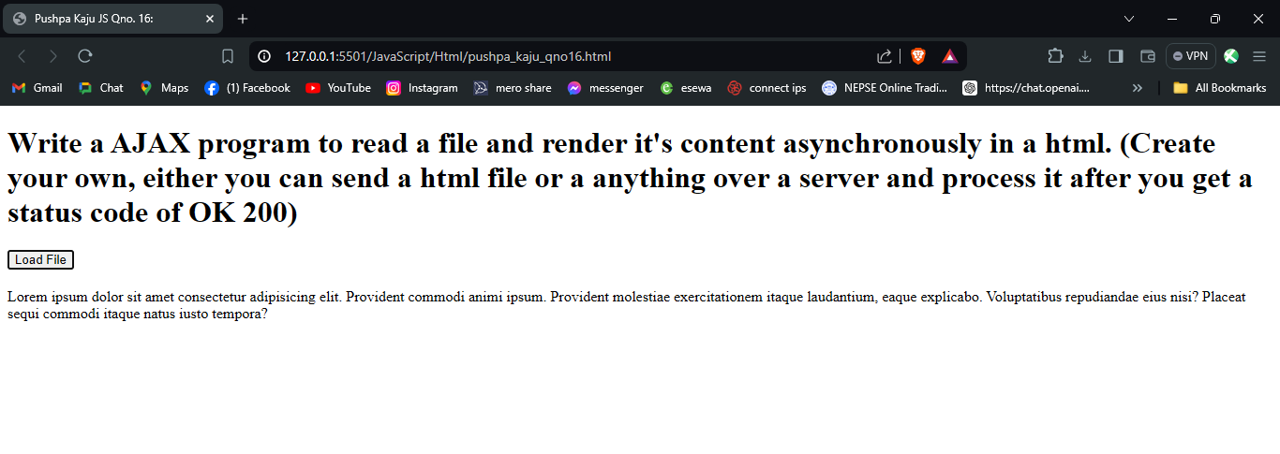

# **XML**

## **XML file**

<?xml version="1.0" encoding="UTF-8"?>

<!DOCTYPE bookstore [

<!ELEMENT bookstore (book+)>

<!ELEMENT book (title, author, year, price)>

<!ATTLIST book category CDATA #REQUIRED>

<!ELEMENT title (#PCDATA)>

<!ATTLIST title lang CDATA #REQUIRED>

<!ELEMENT author (#PCDATA)>

<!ELEMENT year (#PCDATA)>

<!ELEMENT price (#PCDATA)>

]>

<?xml-stylesheet type="text/xsl" href="bookstore.xsl"?>

<bookstore>

<book category="cooking">

<title lang="en">Everyday Italian</title>

<author>Giada De Laurentiis</author>

<year>2005</year>

<price>30.00</price>

</book>

<book category="children">

<title lang="en">Harry Potter</title>

<author>J K. Rowling</author>

<year>2005</year>

<price>29.99</price>

</book>

<book category="web">

<title lang="en">XQuery Kick Start</title>

<author>James McGovern</author>

<year>2003</year>

<price>49.99</price>

</book>

</bookstore>

## **XSL file**

<?xml version="1.0" encoding="UTF-8"?>

<xsl:stylesheet version="1.0" xmlns:xsl="http://www.w3.org/1999/XSL/Transform">

<xsl:template match="/">

<html>

<head>

<style>

.grid-container {

display: grid;

grid-template-columns: repeat(4, 1fr);

gap: 10px;

}

.grid-item {

border: 1px solid #ddd;

padding: 10px;

box-shadow: 0 2px 4px rgba(0,0,0,0.1);

}

</style>

</head>

<body>

<h2>Bookstore</h2>

<div class="grid-container">

<xsl:for-each select="bookstore/book">

<div class="grid-item">

<h3>

<xsl:value-of select="title" /> (<xsl:value-of select="title/@lang" />

)

</h3>

<p>Category: <xsl:value-of select="@category" /></p>

<p>Author: <xsl:value-of select="author" /></p>

<p>Year: <xsl:value-of select="year" /></p>

<p>Price: <xsl:value-of select="price" /></p>

</div>

</xsl:for-each>

</div>

</body>

</html>

</xsl:template>

</xsl:stylesheet>

## **XSD file**

<?xml version="1.0"?>

<xs:schema xmlns:xs="http://www.w3.org/2001/XMLSchema">

<xs:element name="bookstore">

<xs:complexType>

<xs:sequence>

<xs:element name="book" maxOccurs="unbounded">

<xs:complexType>

<xs:sequence>

<xs:element name="title">

<xs:complexType>

<xs:simpleContent>

<xs:extension base="xs:string">

<xs:attribute name="lang" type="xs:string"

use="required" />

</xs:extension>

</xs:simpleContent>

</xs:complexType>

</xs:element>

<xs:element name="author" type="xs:string" />

<xs:element name="year" type="xs:string" />

<xs:element name="price" type="xs:decimal" />

</xs:sequence>

<xs:attribute name="category" type="xs:string" use="required" />

</xs:complexType>

</xs:element>

</xs:sequence>

</xs:complexType>

</xs:element>

</xs:schema>

**Xquery file**

let $doc := doc("pushpa_kaju_bookstore.xml")/bookstore

return

<html>

  <head>

    <title>Books Priced 200 and Above</title>

  </head>

  <body>

    <h1>Books Priced 200 and Above</h1>

    <ul>

    {

      for $book in $doc/book

      where xs:decimal($book/price) >= 200

      return

        <li>

          <p><strong>Title:</strong> {$book/title/text()}</p>

          <p><strong>Category:</strong> {$book/@category}</p>

          <p><strong>Author:</strong> {$book/author/text()}</p>

          <p><strong>Year:</strong> {$book/year/text()}</p>

          <p><strong>Price:</strong> {$book/price/text()}</p>

        </li>

    }

    </ul>

  </body>

</html>

## **DTD file**

<!ELEMENT bookstore (book+)>

<!ELEMENT book (title, author, year, price)>

<!ATTLIST book category CDATA #REQUIRED>

<!ELEMENT title (#PCDATA)>

<!ATTLIST title lang CDATA #REQUIRED>

<!ELEMENT author (#PCDATA)>

<!ELEMENT year (#PCDATA)>

<!ELEMENT price (#PCDATA)>

**OUTPUT:**

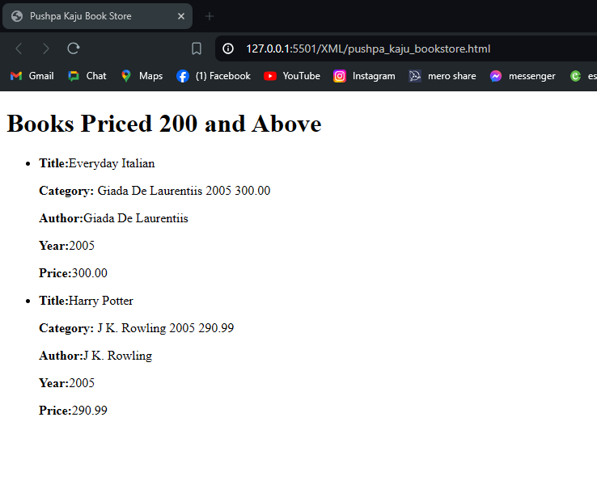

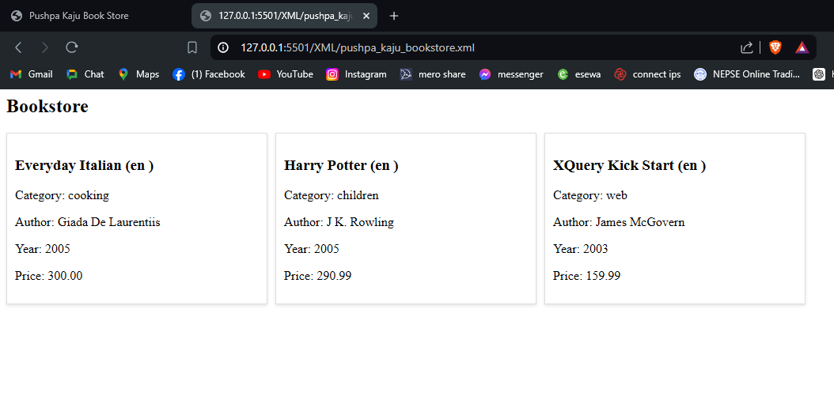

# **Final Lab Work**

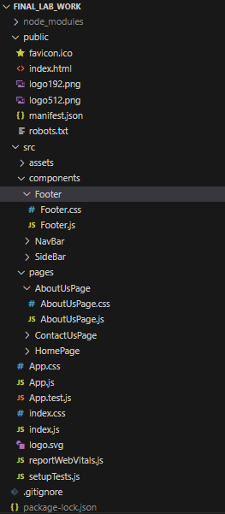

**Figure 1: Folder Structure**

## **Index.js**

import React from 'react';

import ReactDOM from 'react-dom/client';

import './index.css';

import App from './App';

import reportWebVitals from './reportWebVitals';

const root = ReactDOM.createRoot(document.getElementById('root'));

root.render(

<React.StrictMode>

<App />

</React.StrictMode>

);

reportWebVitals();

## **Index.css**

body {

margin: 0;

font-family: -apple-system, BlinkMacSystemFont, 'Segoe UI', 'Roboto', 'Oxygen',

'Ubuntu', 'Cantarell', 'Fira Sans', 'Droid Sans', 'Helvetica Neue',

sans-serif;

-webkit-font-smoothing: antialiased;

-moz-osx-font-smoothing: grayscale;

}

code {

font-family: source-code-pro, Menlo, Monaco, Consolas, 'Courier New',

monospace;

}

## **App.js**

import logo from './logo.svg';

import './App.css';

import { BrowserRouter, Route, Routes, Navigate } from 'react-router-dom';

import Home from './pages/HomePage/HomePage';

import AboutUs from './pages/AboutUsPage/AboutUsPage';

import ContactUs from './pages/ContactUsPage/ContactUsPage';

function App() {

return (

<>

<BrowserRouter>

<Routes>

<Route path="/" element={<Navigate to="/pushpa-kaju-home" />} />

<Route path="/pushpa-kaju-home" element={<Home />} />

<Route path="/pushpa-kaju-about" element={<AboutUs />} />

<Route path="/pushpa-kaju-contact" element={<ContactUs />} />

</Routes>

</BrowserRouter>

</>

);

}

export default App;

## **App.css**

.App {

text-align: center;

}

.App-logo {

height: 40vmin;

pointer-events: none;

}

@media (prefers-reduced-motion: no-preference) {

.App-logo {

animation: App-logo-spin infinite 1s linear;

}

}

.App-header {

background-color: #282c34;

min-height: 100vh;

display: flex;

flex-direction: column;

align-items: center;

justify-content: center;

font-size: calc(10px + 2vmin);

color: white;

}

.App-link {

color: #61dafb;

}

@keyframes App-logo-spin {

from {

transform: rotate(0deg);

}

to {

transform: rotate(360deg);

}

}

## **Components**

### **NavBar**

**NavBar.js**

import React from 'react';

import './NavBar.css';

const NavBar = () => {

const handleOnCLick = () => {

alert('Please send us an email at info@cyclinebtq.com');

}

return <nav className="nav">

<div className="logo">

<svg xmlns="http://www.w3.org/2000/svg" width="16" height="16" fill="currentColor" class="bi bi-hypnotize" viewBox="0 0 16 16">

<path d="m7.949 7.998.006-.003.003.009zm.025-.028v-.03l.018.01zm0 .015.04-.022.01.006v.04l-.029.016-.021-.012zm.049.057v-.014l-.008.01zm-.05-.008h.006l-.006.004z" />

<path fill-rule="evenodd" d="M8 0a8 8 0 1 0 0 16A8 8 0 0 0 8 0M4.965 1.69a6.97 6.97 0 0 1 3.861-.642c.722.767 1.177 1.887 1.177 3.135 0 1.656-.802 3.088-1.965 3.766 1.263.24 2.655-.815 3.406-2.742.38-.975.537-2.023.492-2.996a7.03 7.03 0 0 1 2.488 3.003c-.303 1.01-1.046 1.966-2.128 2.59-1.44.832-3.09.85-4.26.173l.008.021.012-.006-.01.01c.42 1.218 2.032 1.9 4.08 1.586a7.4 7.4 0 0 0 2.856-1.081 6.96 6.96 0 0 1-1.358 3.662c-1.03.248-2.235.084-3.322-.544-1.433-.827-2.272-2.236-2.279-3.58l-.012-.003c-.845.972-.63 2.71.666 4.327a7.4 7.4 0 0 0 2.37 1.935 6.97 6.97 0 0 1-3.86.65c-.727-.767-1.186-1.892-1.186-3.146 0-1.658.804-3.091 1.969-3.768l-.002-.007c-1.266-.25-2.666.805-3.42 2.74a7.4 7.4 0 0 0-.49 3.012 7.03 7.03 0 0 1-2.49-3.018C1.87 9.757 2.613 8.8 3.696 8.174c1.438-.83 3.084-.85 4.253-.176l.005-.006C7.538 6.77 5.924 6.085 3.872 6.4c-1.04.16-2.03.55-2.853 1.08a6.96 6.96 0 0 1 1.372-3.667l-.002.003c1.025-.243 2.224-.078 3.306.547 1.43.826 2.269 2.23 2.28 3.573L8 7.941c.837-.974.62-2.706-.673-4.319a7.4 7.4 0 0 0-2.362-1.931Z" />

</svg>

<div className='name'>

<strong>Cyclone</strong><br></br> Boutique

</div>

</div>

<div className='nav-links'>

<ul>

<li>

<a href="/">

<svg xmlns="http://www.w3.org/2000/svg" width="16" height="16" fill="currentColor" class="bi bi-house" viewBox="0 0 16 16">

<path d="M8.707 1.5a1 1 0 0 0-1.414 0L.646 8.146a.5.5 0 0 0 .708.708L2 8.207V13.5A1.5 1.5 0 0 0 3.5 15h9a1.5 1.5 0 0 0 1.5-1.5V8.207l.646.647a.5.5 0 0 0 .708-.708L13 5.793V2.5a.5.5 0 0 0-.5-.5h-1a.5.5 0 0 0-.5.5v1.293zM13 7.207V13.5a.5.5 0 0 1-.5.5h-9a.5.5 0 0 1-.5-.5V7.207l5-5z" />

</svg>

Home</a>

</li>

<li><a href="/pushpa-kaju-about">

<svg xmlns="http://www.w3.org/2000/svg" width="16" height="16" fill="currentColor" class="bi bi-info-lg" viewBox="0 0 16 16">

<path d="m9.708 6.075-3.024.379-.108.502.595.108c.387.093.464.232.38.619l-.975 4.577c-.255 1.183.14 1.74 1.067 1.74.72 0 1.554-.332 1.933-.789l.116-.549c-.263.232-.65.325-.905.325-.363 0-.494-.255-.402-.704zm.091-2.755a1.32 1.32 0 1 1-2.64 0 1.32 1.32 0 0 1 2.64 0" />

</svg>

About</a>

</li>

<li><a href="/pushpa-kaju-contact">

<svg xmlns="http://www.w3.org/2000/svg" width="16" height="16" fill="currentColor" class="bi bi-headset" viewBox="0 0 16 16">

<path d="M8 1a5 5 0 0 0-5 5v1h1a1 1 0 0 1 1 1v3a1 1 0 0 1-1 1H3a1 1 0 0 1-1-1V6a6 6 0 1 1 12 0v6a2.5 2.5 0 0 1-2.5 2.5H9.366a1 1 0 0 1-.866.5h-1a1 1 0 1 1 0-2h1a1 1 0 0 1 .866.5H11.5A1.5 1.5 0 0 0 13 12h-1a1 1 0 0 1-1-1V8a1 1 0 0 1 1-1h1V6a5 5 0 0 0-5-5" />

</svg>

Contact</a>

</li>

</ul>

</div>

<div className="actions">

<div className="login-btn">

<button onClick={handleOnCLick}>Get Started With a Mail</button>

</div>

</div>

</nav>

}

export default NavBar;

**NavBar.css**

/* Navigation bar styles */

.nav {

height: 10%;

width: 75%;

display: flex;

position: fixed;

top: 0;

justify-content: space-between;

align-items: center;

align-self: center;

background-color: #fff;

padding: 0.5rem 1rem;

color: #ff9a9e;

z-index: 100;

}

.logo {

display: flex;

align-items: center;

}

.logo .name {

font-size: large;

color: #ff9a9e;

}

.logo .name strong {

font-size: large;

color: #ff9a9e;

}

.logo svg {

fill: #ff9a9e;

width: 40px;

height: 40px;

margin-right: 1rem;

}

.nav-links ul {

display: flex;

align-items: center;

justify-content: center;

align-self: center;

list-style: none;

}

.nav-links ul li a {

margin-right: 1rem;

font-size: medium;

justify-content: center;

align-items: center;

display: flex;

color: #feada6;

transition: color 0.3s ease;

text-decoration: none;

}

.nav-links ul li a:hover {

color: #0f2763;

cursor: pointer;

}

.nav-links ul li svg {

margin-right: 0.5rem;

font-size: medium;

}

.actions {

display: flex;

align-items: center;

align-content: center;

justify-content: center;

align-self: center;

}

.actions svg {

width: 30px;

height: 30px;

align-self: center;

fill: #333;

margin-right: 1.5rem;

transition: fill 0.3s ease;

}

.actions svg:hover {

fill: #333;

}

.login-btn button {

background-color: #c99dbb;

color: #fff;

border: none;

padding: 1rem;

border-radius: 5px;

cursor: pointer;

transition: background-color 0.3s ease;

}

.login-btn button:hover {

background-color: #777;

}

### **Footer**

**Footer.js**

import React from 'react';

import './Footer.css';

const Footer = () => {

return <div className='footer'>

<div className='footer-content'>

<div className="footer-col">

<div className="logo">

<svg xmlns="http://www.w3.org/2000/svg" width="16" height="16" fill="currentColor" class="bi bi-hypnotize" viewBox="0 0 16 16">

<path d="m7.949 7.998.006-.003.003.009zm.025-.028v-.03l.018.01zm0 .015.04-.022.01.006v.04l-.029.016-.021-.012zm.049.057v-.014l-.008.01zm-.05-.008h.006l-.006.004z" />

<path fill-rule="evenodd" d="M8 0a8 8 0 1 0 0 16A8 8 0 0 0 8 0M4.965 1.69a6.97 6.97 0 0 1 3.861-.642c.722.767 1.177 1.887 1.177 3.135 0 1.656-.802 3.088-1.965 3.766 1.263.24 2.655-.815 3.406-2.742.38-.975.537-2.023.492-2.996a7.03 7.03 0 0 1 2.488 3.003c-.303 1.01-1.046 1.966-2.128 2.59-1.44.832-3.09.85-4.26.173l.008.021.012-.006-.01.01c.42 1.218 2.032 1.9 4.08 1.586a7.4 7.4 0 0 0 2.856-1.081 6.96 6.96 0 0 1-1.358 3.662c-1.03.248-2.235.084-3.322-.544-1.433-.827-2.272-2.236-2.279-3.58l-.012-.003c-.845.972-.63 2.71.666 4.327a7.4 7.4 0 0 0 2.37 1.935 6.97 6.97 0 0 1-3.86.65c-.727-.767-1.186-1.892-1.186-3.146 0-1.658.804-3.091 1.969-3.768l-.002-.007c-1.266-.25-2.666.805-3.42 2.74a7.4 7.4 0 0 0-.49 3.012 7.03 7.03 0 0 1-2.49-3.018C1.87 9.757 2.613 8.8 3.696 8.174c1.438-.83 3.084-.85 4.253-.176l.005-.006C7.538 6.77 5.924 6.085 3.872 6.4c-1.04.16-2.03.55-2.853 1.08a6.96 6.96 0 0 1 1.372-3.667l-.002.003c1.025-.243 2.224-.078 3.306.547 1.43.826 2.269 2.23 2.28 3.573L8 7.941c.837-.974.62-2.706-.673-4.319a7.4 7.4 0 0 0-2.362-1.931Z" />

</svg>

<div className='name'>

<b>Cyclone</b><br></br> Boutique

</div>

</div>

<br />

<div className="footer-desc">

<strong>Cyclone Boutique</strong>

<p>Cyclone Boutique epitomizes a blend of bold fashion and enduring craftsmanship. Nestled in the heart of urban chic, our boutique offers a curated selection of apparel that marries contemporary trends with timeless elegance. Each piece in our collection is meticulously crafted from the finest materials, ensuring not only impeccable quality but also unmatched comfort and durability. Whether you're seeking a statement piece for a special event or everyday essentials that exude sophistication, Cyclone Boutique is your destination. With a commitment to style innovation and customer satisfaction, we invite you to discover a shopping experience that transcends fashion, leaving a lasting impression with every visit.</p>

</div>

</div>

<div className="footer-col">

<div className="footer-links">

<strong>Quick Links</strong>

<ul>

<li><a href='/'>Home</a></li>

<li><a href='/pushpa-kaju-about'>About</a></li>

<li><a href='/pushpa-kaju-contact'>Contact</a></li>

</ul>

</div>

</div>

<div className="footer-col">

<div className="footer-links">

<strong>Get In Touch</strong>

<div className="touch">

<strong>Asia Headquater</strong>

<div className="detail">

Kupondole-1, Lalitpur, Nepal

</div>

<div className="detail">

+977 1234567890

</div>

<div className="detail">

info@cyclone.com.np

</div>

</div>

<div className="touch">

<strong>Europe Headquater</strong>

<div className="detail">

Chelsea, London, England

</div>

<div className="detail">

+44 20 1234 5678

</div>

<div className="detail">

info@cyclone.com.uk

</div>

</div>

</div>

</div>

</div>

<div className='copyright'>

&copy; 2021 Cyclone Boutique. All Rights Reserved.

</div>

</div>

}

export default Footer;

**Footer.css**

.footer {

justify-content: center;

align-items: center;

}

.footer-content {

display: flex;

justify-content: space-between;

width: 85%;

align-items: flex-start;

}

.footer-content .footer-col {

flex: 1;

font-size: 1.5rem;

text-align: left;

color: #333;

margin-left: 10%;

/* text-align: left; */

}

.footer-content .footer-col strong {

font-size: large;

color: #ff9a9e;

;

}

.footer-content .footer-col ul {

list-style: none;

font-size: medium;

line-height: 30px;

text-align: left;

}

.footer-content .footer-col:first-child {

flex: 3;

font-size: 1.5rem;

text-align: left;

color: #333;

margin-left: 10%;

}

.footer-content .footer-col:last-child {

flex: 1;

font-size: 1.5rem;

text-align: left;

color: #333;

margin-left: 10%;

}

.footer-content .footer-col .footer-desc {

font-size: small;

color: #333;

}

.footer-content .footer-col .touch {

text-align: left;

}

.footer-content .footer-col .touch strong {

font-size: large;

color: #ff9a9e;

}

.footer-content .footer-col .touch .detail {

font-size: medium;

}

.copyright {

text-align: center;

font-size: small;

margin-bottom: 1%;

}

.footer-links ul li a {

color: #333;

text-decoration: none;

transition: color 0.3s ease;

}

.footer-links ul li a:hover {

cursor: pointer;

color: #ff9a9e;

transition: color 0.3s ease;

}

## **Pages**

### **Home**

**HomePage.js**

import NavBar from '../../components/NavBar/NavBar';

import './HomePage.css';

import bgImg from '../../assets/botique.jpg';

import lehenga from '../../assets/designs/lehenga.png';

import suit from '../../assets/designs/suit.png';

import sari from '../../assets/designs/sari.png';

import Footer from '../../components/Footer/Footer';

import kurths from '../../assets/designs/kurtha.png';

import jacket from '../../assets/designs/jacket.png';

import sweater from '../../assets/designs/sweater.png';

import jersey from '../../assets/designs/jersey.png';

import shirt from '../../assets/designs/shirt.png';

import designing from '../../assets/services/design.jpg';

import crafting from '../../assets/services/crafting.jpg';

import tailoring from '../../assets/services/tailoring.jpg';

import delivery from '../../assets/services/delivery.jpg';

import { Helmet } from 'react-helmet';

const Home = () => {

const onVisitStore = () => {

alert('You are visiting the store');

}

const desgindesc = "Designing clothing is an intricate blend of art, science, and cultural expression. It begins with a creative vision, often inspired by trends, historical influences, and personal aesthetics. Designers sketch their ideas, meticulously planning every detail from fabric selection to color palettes, ensuring each piece not only looks appealing but also feels comfortable and functional. They consider the silhouette and structure, balancing innovation with wearability. The process involves understanding textiles and their properties, such as drape and durability, to create garments that are both stylish and long-lasting. Attention to detail is crucial, from the stitching techniques to the placement of embellishments, ensuring high-quality craftsmanship. Designers must also anticipate market trends and consumer preferences, blending originality with commercial appeal. Sustainability is becoming increasingly important, prompting designers to source eco-friendly materials and adopt ethical practices. Ultimately, designing clothing is about creating pieces that resonate with people, allowing them to express their individuality and feel confident in their attire. This fusion of creativity and practicality makes fashion design a dynamic and continually evolving field."

const craftingDesc = "Crafting is a deeply rewarding and meticulous process that transforms raw materials into beautifully finished products. It involves a high level of skill and attention to detail, whether working with wood, metal, textiles, or other mediums. Artisans begin with a concept, often drawing inspiration from tradition, nature, or modern design trends, and then carefully select their materials for quality and suitability. The process of crafting requires a combination of creativity and technical knowledge, as artisans use tools and techniques that have been honed over years, sometimes centuries. Each step, from cutting and shaping to joining and finishing, is performed with precision to ensure the final product is both functional and aesthetically pleasing. Crafting is not just about creating objects; it’s about imbuing each piece with a sense of character and craftsmanship that reflects the maker's dedication and artistry. In a world increasingly dominated by mass production, handcrafted items stand out for their uniqueness and superior quality. They carry a story and a personal touch that machines cannot replicate, making them cherished items in any setting. Through crafting, artisans preserve traditional skills and contribute to a culture of quality and creativity that enriches our lives."

const tailoringDesc = "Tailoring is the art and science of customizing garments to fit an individual's unique body shape, ensuring both comfort and style. This meticulous process begins with precise measurements taken by the tailor, who then selects the appropriate fabric based on the client's preferences and the garment's intended use. Each piece of fabric is cut with precision, taking into account the pattern and grain to ensure a perfect drape. The tailor skillfully assembles the garment using advanced stitching techniques, paying close attention to details such as seams, hems, and linings, which contribute to the overall quality and durability. Fit is paramount in tailoring; a well-tailored garment enhances the wearer’s silhouette, providing a polished and professional appearance. Tailors often make multiple fittings, adjusting the garment based on the client's feedback to achieve the ideal fit. This process not only enhances the garment's aesthetic appeal but also ensures maximum comfort and freedom of movement. Tailoring combines technical expertise with an understanding of fashion trends and individual style, resulting in bespoke pieces that are both timeless and contemporary. In a world of ready-to-wear clothing, tailored garments stand out for their personalized fit and superior craftsmanship, reflecting the tailor's dedication to their craft. Whether it's a bespoke suit, a custom dress, or a perfectly fitted pair of trousers, tailoring celebrates the art of making clothing that is as unique as the individual who wears it."

const deliveryDesc = "Delivery is a vital component of customer service, ensuring products reach buyers swiftly and in excellent condition. This process begins with careful packaging to safeguard items during transit, followed by efficient logistics planning to determine the quickest, most cost-effective routes. Advanced tracking systems keep customers informed, providing real-time updates and transparency. Companies offer various delivery options, including express services, to meet urgent needs. Clear communication about delivery times enhances the customer experience, while efficient handling of returns and exchanges ensures satisfaction. Navigating international shipping regulations smoothly is crucial for global transactions. Timely delivery is especially important in fast-paced industries like fashion. As e-commerce grows, reliable delivery becomes increasingly essential, impacting brand reputation and customer loyalty. Investing in robust delivery solutions is key to thriving in a competitive market."

return (

<div className='content'>

<Helmet>

<title>Pushpa Kaju - Home</title>

</Helmet>

<NavBar />

<div className='hero'>

<div className='hero-text'>

<h1>Welcome to Cyclone Boutique<br />Where you can be yourself.</h1>

</div>

<div className='hero-sub-text'>

Discover timeless elegance and modern comfort with our clothing brand,<br /> blending sophisticated designs with premium fabrics for you.

</div>

<button onClick={onVisitStore}>Visit Store</button>

</div>

<div className='feedback'>

<div className='quot'>

<i>"</i>

</div>

<div className='feedback-text'>

I love the quality of the clothes and the customer service is amazing. I have been shopping here for years and I have never been disappointed.lorem ipsum dolor sit amet, consectetur adipiscing elit. Ut elit tellus, luctus nec ullamcorper mattis, pulvinar dapibus leo.

<p>- Akira Kimbot<br />

<span>Model/Influencer</span>

</p>

</div>

</div>

<div className='eval-wrapper'>

<div className='eval'>

<div className='eval-title'>

<strong>Proven Excellence, Authenticity</strong>

</div>

<div className='eval-sub-title'>

<p>Our products are made with the highest quality materials and are designed to last. <br />We are committed to providing you with the best products and service.</p>

</div>

<div className='eval-cards'>

<div className='eval-card'>

<strong>100+</strong>

<p>Customers</p>

</div>

<div className='eval-card'>

<strong>5</strong>

<p>Countries</p>

</div>

<div className='eval-card'>

<strong>600+</strong>

<p>Designs</p>

</div>

<div className='eval-card'>

<strong>20+</strong>

<p>Categories</p>

</div>

</div>

</div>

</div>

<div className='top-designs'>

<div className='top-designs-title'>

<strong>Top Designs</strong>

</div>

<div className='top-designs-sub-title'>

<p>Discover our top designs for the season. <br />Shop now and get up to 50% off.</p>

</div>

<div className='designs'>

<div className='design'>

<img src={lehenga} alt='design' />

<div className='design-text'>

<strong>Lehenga</strong>

</div>

</div>

<div className='design'>

<img src={kurths} alt='design' />

<div className='design-text'>

<strong>Kurtha</strong>

</div>

</div>

<div className='design'>

<img src={suit} alt='design' />

<div className='design-text'>

<strong>Suit</strong>

</div>

</div>

<div className='design'>

<img src={sari} alt='design' />

<div className='design-text'>

<strong>Saree</strong>

</div>

</div>

<div className='design'>

<img src={jacket} alt='design' />

<div className='design-text'>

<strong>Jackets</strong>

</div>

</div>

<div className='design'>

<img src={sweater} alt='design' />

<div className='design-text'>

<strong>Sweaters</strong>

</div>

</div>

<div className='design'>

<img src={shirt} alt='design' />

<div className='design-text'>

<strong>Shirt</strong>

</div>

</div>

<div className='design'>

<img src={jersey} alt='design' />

<div className='design-text'>

<strong>Jersey</strong>

</div>

</div>

</div>

</div>

<div className='top-designs'>

<div className='top-designs-title'>

<strong>Services we provide</strong>

</div>

<div className='top-designs-sub-title'>

<p>Our Experties.</p>

</div>

<div className='service-block'>

<div className='service'>

<strong>Design</strong>

<p>{desgindesc}</p>

</div>

<div className='service-img'>

<img src={designing} alt='design' />

</div>

</div>

<div className='service-block'>

<div className='service-img'>

<img src={crafting} alt='design' />

</div>

<div className='service'>

<strong>Crafting</strong>

<p>

{craftingDesc}</p>

</div>

</div>

<div className='service-block'>

<div className='service'>

<strong>Tailoring</strong>

<p>{tailoringDesc}</p>

</div>

<div className='service-img'>

<img src={tailoring} alt='design' />

</div>

</div>

<div className='service-block'>

<div className='service-img'>

<img src={delivery} alt='design' />

</div>

<div className='service'>

<strong>Delivery</strong>

<p>{deliveryDesc}</p>

</div>

</div>

</div>

<Footer />

</div>

);

}

export default Home;

**HomePage.css**

.content {

display: flex;

flex-direction: column;

align-items: center;

justify-content: center;

font-size: 2rem;

color: #333;

}

.hero {

text-align: center;

margin-bottom: 5%;

margin-top: 10%;

}

.hero h1 {

font-size: 3rem;

background: linear-gradient(to right, #ff9a9e, #c99dbb, #feada6);

background-clip: text;

color: transparent;

}

.hero .hero-sub-text {

font-size: medium;

color: grey;

margin-bottom: 5%;

}

.hero button {

background: linear-gradient(to right, #ff9a9e, #c99dbb, #feada6);

color: #333;

padding: 0.5rem 2rem;

border: none;

border-radius: 100px;

cursor: pointer;

transition: background-color 0.3s ease;

color: white;

font-weight: bold;

}

.feedback {

width: 75%;

align-items: start;

justify-content: start;

font-size: 2rem;

color: #333;

margin-bottom: 5%;

}

.feedback .quot {

font-size: 7rem;

height: 70px;

text-align: left;

font-family: 'arial';

align-self: flex-start;

margin-left: 5%;

/* background-color: #c99dbb; */

}

.feedback .feedback-text {

font-size: medium;

text-align: left;

font-family: 'arial';

align-self: flex-start;

margin-left: 10%;

margin-top: 0;

line-height: 1.5;

/* background-color: #c99dbb; */

}

.feedback .feedback-text span {

font-size: small;

text-align: left;

font-family: 'arial';

align-self: flex-start;

margin-left: 5%;

margin-top: 0;

color: grey

/* background-color: #c99dbb; */

;

}

.eval-wrapper {

width: 100%;

display: flex;

flex-direction: column;

align-items: center;

justify-content: center;

background-color: red;

margin-bottom: 2%;

background-image: url('../../assets/botique.jpg');

background-repeat: no-repeat;

background-size: cover;

background-attachment: fixed;

padding-top: 5%;

}

.eval {

width: 65%;

display: flex;

flex-direction: column;

align-items: center;

justify-content: center;

font-size: 2rem;

color: #333;

}

.eval .eval-sub-title {

font-size: medium;

color: grey;

text-align: center;

margin-bottom: 0;

}

.eval .eval-cards {

width: 100%;

display: flex;

align-items: center;

justify-content: space-between;

color: #333;

margin-bottom: 5%;

}

.eval .eval-cards .eval-card {

display: flex;

flex-direction: column;

align-items: center;

justify-content: center;

color: #333;

margin-bottom: 5%;

padding-top: 5%;

}

.eval .eval-cards .eval-card strong {

font-size: larger;

/* background-color: #ff9a9e; */

}

.eval .eval-cards .eval-card p {

font-size: smaller;

/* background-color: #333; */

margin-top: 0;

}

.top-designs {

width: 65%;

display: flex;

flex-direction: column;

align-items: center;

justify-content: center;

font-size: 2rem;

color: #333;

}

.top-designs .top-designs-sub-title {

font-size: medium;

color: grey;

text-align: center;

margin-bottom: 0;

}

.top-designs .designs {

display: grid;

grid-template-columns: repeat(4, 1fr);

grid-auto-rows: auto;

/* Allow rows to adjust to content */

gap: 20px;

/* Gap between grid items */

margin-bottom: 5%;

}

.top-designs .designs .design {

display: flex;

flex-direction: column;

justify-content: space-between;

margin: 3%;

/* border: #333 1px solid; */

padding: 3%;

border-radius: 10px;

height: 100%;

/* Ensure the design item takes full height of its grid cell */

}

.top-designs .designs .design img {

width: 100%;

height: 100%;

/* Ensure the image takes full height of its container */

object-fit: cover;

border-radius: 10px;

}

.top-designs .designs .design .design-text {

font-size: medium;

color: grey;

text-align: center;

}

.service-block {

display: flex;

align-items: center;

justify-content: flex-end;

font-size: 2rem;

color: #333;

margin-bottom: 5%;

}

.service-block .service {

flex: 1;

margin: 0 5%;

}

.service-block .service strong {

font-size: large;

color: #333;

}

.service-block .service p {

font-size: small;

color: #333;

}

.service-block .service-img {

flex: 1;

}

.service-block .service-img img {

width: 100%;

height: auto;

max-width: 300px;

/* Adjust the maximum width as needed */

max-height: 300px;

/* Adjust the maximum height as needed */

object-fit: cover;

background-color: red;

}

### **About Us**

**AboutUsPage.js**

import React from 'react';

import './AboutUsPage.css';

import NavBar from '../../components/NavBar/NavBar';

import Footer from '../../components/Footer/Footer';

import tailorIllustration from '../../assets/tailor_ilus.png';

import ceo from '../../assets/BOD/CEO.jpg';

import cfo from '../../assets/BOD/CFO.jpg';

import cto from '../../assets/BOD/CTO.jpg';

import branchManagerNepal from '../../assets/BOD/branch-manager-nepal.jpg';

import branchManagerIndia from '../../assets/BOD/branch-manager-india.jpg';

import branchManagerJapan from '../../assets/BOD/branch-manager-japan.jpg';

import branchManagerKorea from '../../assets/BOD/branch-manager-korea.jpg';

import customerSupportAsia from '../../assets/BOD/customer-support-asia.jpg';

import customerSupportAmerica from '../../assets/BOD/customer-support-america.png';

import customerSupportEurope from '../../assets/BOD/customer-support-europe.jpg';

import salesMarketingLead from '../../assets/BOD/salese-marketing-lead.png';

import salesMarketingAsst from '../../assets/BOD/sales-asst.png';

import techLead from '../../assets/BOD/tech-lead.jpeg';

import techAsst from '../../assets/BOD/tech-asst.png';

import finance from '../../assets/BOD/finance-associate.png';

import { Helmet } from 'react-helmet';

const AboutUs = () => {

return <div className='content'>

<Helmet>

<title>Pushpa Kaju - About Us</title>

</Helmet>

<NavBar />

<div className='about-us-wrapper'>

<div className='about-us'>

<div className='about-us-txt'>

<div className='about-us-header'>

<strong>About Us</strong>

</div>

<div className='about-us-content'>

<p>Cyclone Boutique epitomizes a blend of bold fashion and enduring craftsmanship. Nestled in the heart of urban chic, our boutique offers a curated selection of apparel that marries contemporary trends with timeless elegance. Each piece in our collection is meticulously crafted from the finest materials, ensuring not only impeccable quality but also unmatched comfort and durability. Whether you're seeking a statement piece for a special event or everyday essentials that exude sophistication, Cyclone Boutique is your destination. With a commitment to style innovation and customer satisfaction, we invite you to discover a shopping experience that transcends fashion, leaving a lasting impression with every visit.</p>

</div>

</div>

<div className='about-us-img'>

<img src={tailorIllustration} height={300} width={300} />

</div>

</div>

</div>

<div className='team'>

<div className='team-title'>

<strong>Our Team</strong>

</div>

<div className='team-sub-title'>

<p>Get on board and meet out professionals.</p>

</div>

<div className='members'>

<div className='member'>

<img src={ceo} alt='design' height={150} width={100} />

<div className='design-text'>

<strong>Pushpa Kaju</strong><br />

<span>Co-Founder/CEO</span>

</div>

</div>

<div className='member'>

<img src={cfo} alt='design' height={150} width={100} />

<div className='design-text'>

<strong>Reshma Rai</strong><br />

<span>Co-Founder/CFO</span>

</div>

</div>

<div className='member'>

<img src={cto} alt='design' height={150} width={100} />

<div className='design-text'>

<strong>Ajnesh Duwal</strong><br />

<span>Co-Founder/CTO</span>

</div>

</div>

<div className='member'>

<img src={branchManagerNepal} alt='design' height={150} width={100} />

<div className='design-text'>

<strong>Nishan Paudel</strong><br />

<span>Branch Manager - Nepal</span>

</div>

</div>

<div className='member'>

<img src={branchManagerIndia} alt='design' height={150} width={100} />

<div className='design-text'>

<strong>krishna A. Gainju</strong><br />

<span>Branch Manager - India</span>

</div>

</div>

<div className='member'>

<img src={branchManagerJapan} alt='design' height={150} width={100} />

<div className='design-text'>

<strong>Soniya Prajapati</strong><br />

<span>Branch Manager - Japan</span>

</div>

</div>

<div className='member'>

<img src={branchManagerKorea} alt='design' height={150} width={100} />

<div className='design-text'>

<strong>Binila Rajchal</strong><br />

<span>Branch Manager - Korea</span>

</div>

</div>

<div className='member'>

<img src={customerSupportAsia} alt='design' height={150} width={100} />

<div className='design-text'>

<strong>Ayusha Shreatha</strong><br />

<span>Customer Support - Asia</span>

</div>

</div>

<div className='member'>

<img src={customerSupportAmerica} alt='design' height={150} width={100} />

<div className='design-text'>

<strong>Deena Jakibanjar</strong><br />

<span>Customer Support - America</span>

</div>

</div>

<div className='member'>

<img src={customerSupportEurope} alt='design' height={150} width={100} />

<div className='design-text'>

<strong>Pratisha Manandhar</strong><br />

<span>Customer Support - Europe</span>

</div>

</div>

<div className='member'>

<img src={salesMarketingLead} alt='design' height={150} width={100} />

<div className='design-text'>

<strong>Priyanka Chaguthi</strong><br />

<span>Sales/Marketing Lead</span>

</div>

</div>

<div className='member'>

<img src={salesMarketingAsst} alt='design' height={150} width={100} />

<div className='design-text'>

<strong>Bibisha Thakuri</strong><br />

<span>Sales/Marketing Asst.</span>

</div>

</div>

<div className='member'>

<img src={techLead} alt='design' height={150} width={100} />

<div className='design-text'>

<strong>Shirish Jonchhen</strong><br />

<span>Tech Lead</span>

</div>

</div>

<div className='member'>

<img src={techAsst} alt='design' height={150} width={100} />

<div className='design-text'>

<strong>Rabi Shrestha</strong><br />

<span>Tech Asst.</span>

</div>

</div>

<div className='member'>

<img src={finance} alt='design' height={150} width={100} />

<div className='design-text'>

<strong>Bibek Shrestha</strong><br />

<span>Finance Associate</span>

</div>

</div>

</div>

</div>

<div className='client'>

<div className='client-form'>

<div className='client-form-slogan'>

<b>If you have ideas, you have the main asset you need, and there isn’t any

limit to what you can do with your business and your life. Ideas are any man’s

greatest asset.</b><br />

<p>- Harvey S. Firestone</p>

</div>

<div className='client-form-title'>

<strong>Give an idea about your requirements.</strong>

<form>

<input type='text' placeholder='Name' />

<input type='email' placeholder='Email' />

<input type='number' placeholder='Phone' />

<textarea placeholder='Requirements' rows={3} ></textarea>

<button>Submit</button>

</form>

</div>

</div>

</div>

<Footer />

</div>

}

export default AboutUs;

**AboutUsPage.css**

.about-us-wrapper {

align-items: center;

background-image: url('https://intopros.com/static/media/vector.fe46a6d6ef9d25e4cfef.png');

background-position: 0px -60px;

background-size: cover;

display: flex;

padding-top: 6rem;

padding-bottom: 15%;

}

.about-us {

display: flex;

align-items: flex-end;

justify-content: space-between;

width: 60%;

margin-left: 20%;

}

.about-us .about-us-txt {

flex: 1;

}

.about-us .about-us-header strong {

font-size: larger;

font-weight: bold;

background: linear-gradient(to right, #ff9a9e, #c99dbb, #feada6);

background-clip: text;

color: transparent;

}

.about-us .about-us-content {

font-size: small;

padding: 10px;

}

.about-us .about-us-img {

flex: 1;

align-self: flex-end;

text-align: center;

margin-bottom: -15%;

/* margin-left: -15%; */

/* margin-top: 3/0%; */

}

.team {

width: 65%;

display: flex;

flex-direction: column;

align-items: center;

justify-content: center;

font-size: 2rem;

color: #333;

margin-bottom: 8%;

}

.team .team-sub-title p {

font-size: medium;

color: grey;

text-align: center;

margin-bottom: 5%;

}

.team .members {

display: grid;

grid-template-columns: repeat(5, 1fr);

gap: 2%;

/* Added gap to control space between items */

justify-content: center;

}

.team .members .member {

margin: 3%;

padding: 3%;

border-radius: 10px;

text-align: center;

}

.team .members .member img {

width: 150px;

/* Set a fixed width */

height: 150px;

/* Set a fixed height */

border-radius: 1000px;

object-fit: cover;

}

.team .members .member .design-text {

font-size: medium;

color: grey;

text-align: center;

}

.client {

display: flex;

align-items: flex-end;

justify-content: center;

font-size: 2rem;

color: #333;

margin-bottom: 5%;

padding: 5%;

background-image: url('../../assets/tailor_bg.jpg');

background-repeat: no-repeat;

/* background-size: cover; */

background-position: left center;

/* background-color: pink; */

}

.client-form {

display: flex;

width: 85%;

/* background-color: red; */

}

.client-form .client-form-slogan {

flex: 1;

padding-right: 30%;

align-content: center;

/* width: 75%; */

}

.client-form .client-form-slogan b {

font-size: x-large;

text-shadow: 2px 2px 6px rgba(225, 225, 225, 1000);

/* Shadow effect */

color: black

}

.client-form .client-form-slogan p {

font-size: small;

text-align: right;

width: 100%;

text-shadow: 2px 2px 6px rgba(225, 225, 225, 1000);

/* Shadow effect */

color: black

}

.client-form .client-form-title {

flex: 1;

display: flex;

flex-direction: column;

border: #333 1px solid;

border-radius: 5px;

box-shadow: #333 2px 5px 20px;

padding: 5%;

background-color: white;

}

.client-form .client-form-title form {

flex: 1;

display: flex;

flex-direction: column;

justify-content: space-around;

width: 100%;

border-radius: 20px;

padding: 5% 0;

}

.client-form .client-form-title form input[type="text"],

.client-form .client-form-title form input[type="email"],

.client-form .client-form-title form input[type="number"] {

width: 100%;

margin-bottom: 5%;

border-bottom: grey 1px solid;

border-top: none;

border-left: none;

border-right: none;

}

.client-form .client-form-title form input[type="text"]:focus,

.client-form .client-form-title form input[type="email"]:focus,

.client-form .client-form-title form input[type="number"]:focus {

border-bottom-color: pink;

outline: none;

/* Optional: remove the default outline */

}

.client-form .client-form-title form textarea {

width: 100%;

margin-bottom: 5%;

border: none;

border-bottom: grey 1px solid;

/* padding: 10px 0; */

resize: vertical;

box-sizing: border-box;

transition: border-bottom-color 0.3s ease;

font-family: inherit;

font-size: small;

line-height: 1.5em;

}

.client-form .client-form-title form textarea:focus {

border-bottom-color: pink;

/* Change bottom border color to pink when focused */

outline: none;

/* Remove default outline */

}

.client-form .client-form-title form button {

background-color: #ff9a9e;

color: white;

border: none;

padding: 10px 20px;

border-radius: 20px;

font-size: medium;

cursor: pointer;

transition: background-color 0.3s ease, transform 0.3s ease;

display: inline-block;

text-transform: uppercase;

box-shadow: 0 2px 5px rgba(0, 0, 0, 0.15);

}

.client-form .client-form-title form button:hover {

background-color: #ff7b81;

transform: translateY(-2px);

}

.client-form .client-form-title form button:active {

background-color: #e86b6f;

transform: translateY(0);

}

.client-form .client-form-title strong {

font-size: x-large;

}

### **Contact Us**

**ContactUsPage.js**

import React from 'react';

import './ContactUsPage.css';

import NavBar from '../../components/NavBar/NavBar';

import Footer from '../../components/Footer/Footer';

import { Helmet } from 'react-helmet';

const ContactUs = () => {

return <div className='content'>

<Helmet>

<title>Pushpa Kaju - Contact Us</title>

</Helmet>

<NavBar />

<div className='contact-us-content'>

<div className='contact-us-header'>

<strong>We are here for you,<br />Contact Us at Anytime</strong>

<p>Have any questions about our services or just wanna have a chat with us? Please Reach out.</p>

</div>

<div className='contact-us-options'>

{/* mail */}

<div className='contact-us-option'>

<div className='contact-us-option-icon'>

<svg xmlns="http://www.w3.org/2000/svg" width="16" height="16" fill="currentColor" class="bi bi-geo-alt" viewBox="0 0 16 16">

<path d="M12.166 8.94c-.524 1.062-1.234 2.12-1.96 3.07A32 32 0 0 1 8 14.58a32 32 0 0 1-2.206-2.57c-.726-.95-1.436-2.008-1.96-3.07C3.304 7.867 3 6.862 3 6a5 5 0 0 1 10 0c0 .862-.305 1.867-.834 2.94M8 16s6-5.686 6-10A6 6 0 0 0 2 6c0 4.314 6 10 6 10" />

<path d="M8 8a2 2 0 1 1 0-4 2 2 0 0 1 0 4m0 1a3 3 0 1 0 0-6 3 3 0 0 0 0 6" />

</svg>

</div>

<div className='contact-us-option-title'>

Visit Us<br />

<span>at out physical store</span>

</div>

<div className='contact-us-option-link'>

<a href='https://maps.app.goo.gl/DduFHEWntjLPaGgQ9' target='_blank'>Google Maps &gt;</a>

</div>

</div>

<div className='contact-us-option'>

<div className='contact-us-option-icon'>

<svg xmlns="http://www.w3.org/2000/svg" width="16" height="16" fill="currentColor" class="bi bi-envelope" viewBox="0 0 16 16">

<path d="M0 4a2 2 0 0 1 2-2h12a2 2 0 0 1 2 2v8a2 2 0 0 1-2 2H2a2 2 0 0 1-2-2zm2-1a1 1 0 0 0-1 1v.217l7 4.2 7-4.2V4a1 1 0 0 0-1-1zm13 2.383-4.708 2.825L15 11.105zm-.034 6.876-5.64-3.471L8 9.583l-1.326-.795-5.64 3.47A1 1 0 0 0 2 13h12a1 1 0 0 0 .966-.741M1 11.105l4.708-2.897L1 5.383z" />

</svg>

</div>

<div className='contact-us-option-title'>

Mail Us<br />

<span>From your Email app</span>

</div>

<div className='contact-us-option-link'>

<a href='mailto:info@cyclonebtq.com?subject=Inquiry&body=Message%20Here%20%2C%0D%0A%0D%0A'> info@cyclonebtq.com</a>

</div>

</div>

<div className='contact-us-option'>

<div className='contact-us-option-icon'>

<svg xmlns="http://www.w3.org/2000/svg" width="16" height="16" fill="currentColor" class="bi bi-telephone" viewBox="0 0 16 16">

<path d="M3.654 1.328a.678.678 0 0 0-1.015-.063L1.605 2.3c-.483.484-.661 1.169-.45 1.77a17.6 17.6 0 0 0 4.168 6.608 17.6 17.6 0 0 0 6.608 4.168c.601.211 1.286.033 1.77-.45l1.034-1.034a.678.678 0 0 0-.063-1.015l-2.307-1.794a.68.68 0 0 0-.58-.122l-2.19.547a1.75 1.75 0 0 1-1.657-.459L5.482 8.062a1.75 1.75 0 0 1-.46-1.657l.548-2.19a.68.68 0 0 0-.122-.58zM1.884.511a1.745 1.745 0 0 1 2.612.163L6.29 2.98c.329.423.445.974.315 1.494l-.547 2.19a.68.68 0 0 0 .178.643l2.457 2.457a.68.68 0 0 0 .644.178l2.189-.547a1.75 1.75 0 0 1 1.494.315l2.306 1.794c.829.645.905 1.87.163 2.611l-1.034 1.034c-.74.74-1.846 1.065-2.877.702a18.6 18.6 0 0 1-7.01-4.42 18.6 18.6 0 0 1-4.42-7.009c-.362-1.03-.037-2.137.703-2.877z" />

</svg>

</div>

<div className='contact-us-option-title'>

Call Us<br />

<span>From your Mobile Phone</span>

</div>

<div className='contact-us-option-link'>

<a href='/pushpa-kaju-contact'>+977 9876543210 </a>

</div>

</div>

</div>

</div>

<div className='contact-us-time'>

We'll get back to you as soon as possible. Out team is available 8am - 6pm on weekdays.

</div>

<Footer />

</div>

}

export default ContactUs;

**ContactUsPage.css**

.contact-us-content {

padding-top: 10%;

text-align: center;

background-image: url('../../assets/contact-bg.jpg');

background-repeat: no-repeat;

background-size: cover;

/* background-attachment: fixed; */

background-position: left 170%;

width: 100%;

}

.contact-us-content .contact-us-header {

padding-bottom: 5%;

}

.contact-us-content .contact-us-header strong {

background: linear-gradient(to right, #ff9a9e, #c99dbb, #feada6);

background-clip: text;

color: transparent;

}

.contact-us-content .contact-us-header p {

font-size: small;

}

.contact-us-options {

display: flex;

justify-content: center;

margin-bottom: 5%;

}

.contact-us-options .contact-us-option {

text-align: center;

display: flex;

flex-direction: column;

align-items: center;

background-color: white;

padding: 2% 5%;

border-radius: 10px;

/* border: #333 1px solid; */

margin-left: 5%;

/* width: 2rem; */

box-shadow: 2px 2px 5px 0 rgb(100, 99, 99);

}

.contact-us-options .contact-us-option .contact-us-option-icon {

padding: 5%;

height: 50px;

width: 50px;

border-radius: 100%;

background-color: #ff9a9e;

}

.contact-us-options .contact-us-option .contact-us-option-icon svg {

height: 50px;

width: 50px;

}

.contact-us-options .contact-us-option .contact-us-option-title {

font-size: medium;

font-weight: bold;

margin-top: 5%;

}

.contact-us-options .contact-us-option .contact-us-option-title span {

font-size: small;

font-weight: normal;

}

.contact-us-options .contact-us-option .contact-us-option-link {

padding: 0.5% 0;

}

.contact-us-options .contact-us-option .contact-us-option-link a {

text-decoration: none;

font-size: medium;

padding: 10px 50px;

/* background-color: green; */

border-radius: 5px;

font-weight: bold;

color: green;

/* width: 60%; */

}

.contact-us-time {

display: flex;

justify-content: center;

margin-bottom: 5%;

font-size: small;

}

.contact-us-options .contact-us-option:first-child .contact-us-option-link a {

text-decoration: none;

font-size: medium;

padding: 10px 50px;

background-color: green;

border-radius: 5px;

font-weight: bold;

color: white;

/* width: 60%; */

}

## **package.json**

{

"name": "final_lab_work",

"version": "0.1.0",

"private": true,

"dependencies": {

"@testing-library/jest-dom": "^5.17.0",

"@testing-library/react": "^13.4.0",

"@testing-library/user-event": "^13.5.0",

"bootstrap-icons": "^1.11.3",

"react": "^18.3.1",

"react-dom": "^18.3.1",

"react-helmet": "^6.1.0",

"react-router-dom": "^6.23.1",

"react-scripts": "5.0.1",

"web-vitals": "^2.1.4"

},

"scripts": {

"start": "react-scripts start",

"build": "react-scripts build",

"test": "react-scripts test",

"eject": "react-scripts eject"

},

"eslintConfig": {

"extends": [

"react-app",

"react-app/jest"

]

},

"browserslist": {

"production": [

">0.2%",

"not dead",

"not op_mini all"

],

"development": [

"last 1 chrome version",

"last 1 firefox version",

"last 1 safari version"

]

}

}

## **OUPUT:**

